





I N C H R I S T I A N I T Y
FIRST STEPS
He is like a tree planted by streams of water that yields its fruit in its season, and its leaf does not wither. In all that he does, he prospers. Psalm 1:3
1st Book
D I S C I P L E S H I P Series

Table of Contents

Book 1 – First Steps In Christianity

A Story – An Introduction to Our Story p. 2
- Knowing God p. 6
- Introduction to the Bible p. 14
- Introduction to Knowing the God of Creation p. 21
- A Discussion about Wood and God p. 28
- Introduction to Prayer p. 34
- Introduction to Discipleship p. 37
- Introduction to the Reality of Temptation p. 41



Go, make disciples!
A Story, An Introduction to Our Story

Greetings! Welcome to our church and to this discipleship experience! This material is designed for those seeking the truth. Jesus says, “I am the way, the truth and the life”. That is what we believe, so we will allow Jesus to show you the way to truth, the way to God and the way to eternal life, to heaven.
But all truth-seekers come with questions.
So, who is this Jesus and how is he the Savior of all mankind?
Who is this God of the Christians?
How can I find out more? That is what these studies are for, you have come to the right place.
How does one become a Christian? This is perhaps a question for the future, but we will start here.
We will use a story of Jesus with a woman from Samaria. It is also my story, and it is every seeker’s story. Is it your story? What is startling about this story is that we discover that Jesus, that the Lord, is seeking us, even more than we are seeking him… The story (The Gospel of John chapter 4, verses 7-30 and 39-43):

There came a woman of Samaria to draw water. Jesus said to her, “Give me a drink.” (For his disciples had gone away into the city to buy food.) The Samaritan woman said to him, “How is it that you, a Jew, ask for a drink from me, a woman of Samaria?” (For Jews have no dealings with Samaritans.) (vs. 7-9)
In our world we are surrounded by prejudices, by division. We are surrounded by groups in conflict, even in our own family. We discover the truth that Jesus (the Lord) pays no attention to this animosity, to these cultural factions and friction. We are startled to discover that Jesus is seeking and accepts anyone, independent of their caste or their past, independent of whether they are a man or a woman. He loves everyone. The woman was surprised and said so.
Jesus answered her, "If you knew the gift of God, and who it is that is saying to you, 'Give me a drink,' you would have asked him, and he would have given you living water." The woman said to him, "Sir, you have nothing to draw water with, and the well is deep. Where do you get that living water? Are you greater than our father Jacob? He gave us the well and drank from it himself, as did his sons and his livestock."
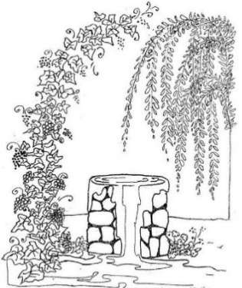
In our world, we are so accustomed to our limitations that we don’t see any other way, no hope of an open door, or a change of our circumstance. The woman didn’t understand, didn’t see the truth. Perhaps it was pride. “Are you greater than our father…?” The woman from Samaria was startled to hear that there was something, someone that could offer life, a promise of unending, abundant life. But, her doubts, her inability to see any possibility of hope, quickly filled her heart and mind, just like it does in our own heart and mind, after many years of seeking, of failure.
Jesus said to her, "Everyone who drinks of this water will be thirsty again, but whoever drinks of the water that I will give him will never be thirsty again. The water that I will give him will become in him a spring of water welling up to eternal life." The woman said to him, "Sir, give me this water, so that I will not be thirsty or have to come here to draw water."
Jesus told her the truth, (very kindly, I think). “I can change your circumstances, I can give you life that will never fade, that will last forever.” And here is another startling discovery, this “water” of life, that Jesus offers, will be within us, welling up and overflowing. We see in the woman of Samaria a glimmer of hope! “Give me this water!” She begins to hope that it does exist, life such as this. And, when we hear Jesus, the truth falls on our ears and sinks into our hearts, we also hope.
Jesus said to her, "Go, call your husband, and come here." The woman answered him, "I have no husband." Jesus said to her, "You are right in saying, 'I have no husband'; for you have had five husbands, and the one you now have is not your husband. What you have said is true."
“OH NO! This person who has offered me so much, he knows the truth!” These could have been her very thoughts. Yes, he knows the truth, the whole truth about us. I am a sinner. I have messed up my life. I am guilty and broken, beyond repair. The true God knows all things, how startling that truth was to her, and it is to you and me. If God knows all our faults, all our sin, then hope is gone…so we think.
The woman said to him, "Sir, I perceive that you are a prophet. Our fathers worshiped on this mountain, but you say that in Jerusalem is the place where people ought to worship." Jesus said to her, "Woman, believe me, the hour is coming when neither on this mountain nor in Jerusalem will you worship the Father. You worship what you do not know; we worship what we know, for salvation is from the Jews.

The woman of Samaria begins to build a wall between her and Jesus. She changes the subject, to shut out the pain in her life. She points out their religious differences, “You worship in a different place you worship in a different way.” This is a very common thing to feel and to say in Asia. But Jesus reveals a hard truth we sometimes need to hear, “You worship what you do not know.” Do we really know what we worship? Wouldn’t it be wonderful to really know? Jesus says that salvation is from the Jews. He does not say that the one true God is theirs, is Jewish, for He is the God of all nations, of all people. That is the truth, it is also a new thought for many. But the Jews worship the true God because God had revealed himself through this small nation.
But the hour is coming, and is now here, when the true worshipers will worship the Father in spirit and truth, for the Father is seeking such people to worship him. God is spirit, and those who worship him must worship in spirit and truth.
Jesus startles her again, he himself breaks down the wall that the woman of Samaria had built. He says, “These things don’t matter, the truth is that anyone can worship God, from anywhere!” Really? How can that be? Because “God is spirit and those who worship Him must worship in spirit and in truth.” And Jesus repeats it again here, that God himself is seeking all people, because they are important. There are no religious walls, there is no prejudice, there are no barriers…not even sin and failure.
The woman said to him, "I know that Messiah is coming (he who is called Christ). When he comes, he will tell us all things." Jesus said to her, "I who speak to you am he."
The woman from Samaria says, as if clinging to her only hope, her last chance, “All our lives we have been waiting for a Messiah, One that will extend salvation to all nations. He knows all things, including how we can be free from our own sin and shame. The Messiah will know how we can reach the grace and the love of God. Could you be the Messiah?”
And Jesus said, “Yes, I am he. I have come.” The woman of Samaria met Jesus, she met the Truth, she met the Way, and found eternal Life. That is the way to become a Christian. In other religions you are born into the religion, it is a part of the culture, and one follows the rituals.
In Christianity too, you must be born into Christianity, into the family of God. Only this can happen after you have already been born. Jesus says in the John chapter 3, “You must be born again”. But these are glorious words because they mean that the Lord gives us a new beginning! He transforms our lives for something greater, something better.
It happens when we meet Jesus. Have you met him? Some see Jesus in visions or dreams. Others, seeking, find the Truth in the Bible. Others see a victorious life in others and find hope in their testimony to cry out to Jesus, the Way. Jesus is the truth that sets all of us free.
What has led you here, my friend? I don’t think it is an accident that you are here. May all your questions be answered, your doubts replaced with certainty, and your seeking lead you home, to Jesus. This discipleship material is a part of that Journey.
Jesus’s last words before being taken up to heaven were, “Go and make disciples of all nations.” (Matthew 28:19). Discipleship is how we grow, it is how we follow the Way, Jesus. Discipleship is God’s way for uniting all those who believe. It is God’s plan for reaching those who still have not heard, those who are lost, those who are seeking in every nation. Let’s go!
Lesson 1
Knowing God
Text: Acts 17:22-34
Key Verse: Acts 17:23b

“What therefore you worship as unknown, this I proclaim to you.”

Introduction:


In almost every culture of the world, people believe in a god who created all things. Usually, this god is more distant and unknown because, as the maker of all things, they are unimaginably powerful; the distance between such a god and humanity seems insurmountably great. When the early church was just beginning to grow, the cultures around them were no different in their beliefs. In fact, Plato, one of the greatest Greek philosophers, is known to have said, "the father and maker of all this universe is beyond finding out.”

In our lesson today, we will learn about the work of the Apostle Paul, a chosen servant of the Creator God, and the words that he spoke to a society with that same belief. Being an apostle meant he was a leader in the church who had met Jesus personally and had been appointed by Him to do His ministry. Having been given the work of proclaiming God’s truth to the nations, Paul traveled far and wide, far enough that he made it from the Middle East to Europe—which is where today’s story takes place.

Studying the Word:
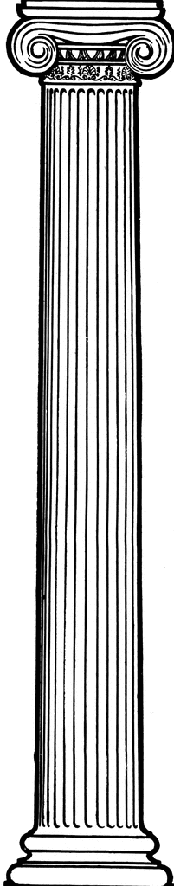
Part 1: Seeking Truth—Who is speaking?

A. Who is Paul?

As Paul walked for the first time through the city of Athens, in Greece, he saw many temples and idols. The Bible says that “his spirit was provoked within him.” Paul was “burdened” by this—his heart was heavy, it hurt for the people that were looking to gods that could not help them. So, he sought to tell this people about the one true God, the God of all creation, the God unknown to them. His sermon that he preached to the leadership council in Athens, the Areopagus, is what we will be looking at today. It can be found in Acts 17:22-34.

But before we get deeper into the message spoken there, who is the speaker? Who is Paul?

Paul was a Jew, one of God’s chosen people. The Lord chose the Israelites as His people to help Him reveal Himself to the world and its nations. The Old Testament tells this story. Paul, being a Jew, was someone who was familiar with all the history of Israel and how the God of Creation had worked with them.

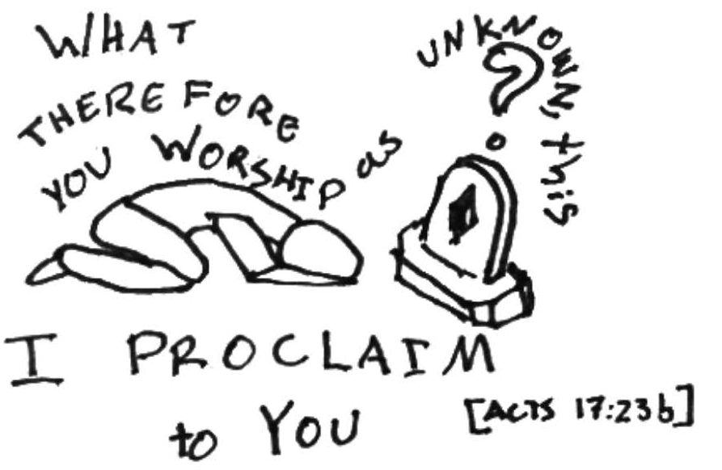
The Greeks and the other nations around them did not have the Bible, nor did they know of the God of Creation, the True God. As we mentioned, most cultures recognize that there is a God who created the world, who made us, who initiated all things—but often He is the least known. Such it was in Athens. Paul found an altar to “the unknown God,” and, since he knew this God of creation, he used it as an opportunity to proclaim what God had taught his people.

Part 2: Seeking Truth—What Does God Not Want?

A. Temples - Acts 17:22-25

What does the God of Creation reveal to us about Himself in Acts 17:24-25?

Is this different from how most gods are? In what way?


The Creator God’s Word contradicts this common pattern of thinking. Through Paul’s sermon, the idea of this kind of worship—that of humans sustaining and giving life to the gods—is described as illogical. After all, if the Creator God made everything, why would He need us to bring Him something from the world He made? He says in verse 25 that God is not “served by human hands, as though he needed anything.” The Creator God is not dependent upon us. Why would He be?

So, if we want to worship and serve God, how can we? We will get to these answers soon, but first, let’s discuss one more instance of misplaced worship.

B. Images – Acts 17:26-29

Looking in verse 29, what else does this passage have to say about God’s divinity?

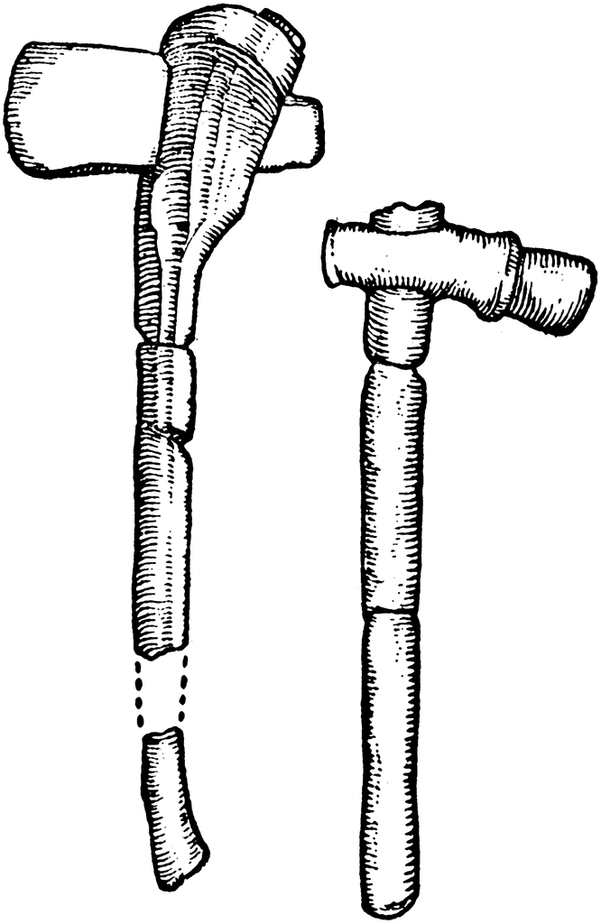
Paul shows us that our own attempts at making a god or making a representation of a god are not, in fact, honoring to the God above all gods, the True God, the God of Creation. Reducing God, above and beyond anything in this world, to an image of a beast or a man, or of anything in nature, is a mistake done in ignorance. Why would our bowing down to an image of something He created be honoring to the Creator? In the end, we would be worshipping nothing more than something we had made with our own hands, something accessible and visible, and not Him who Created all things.

God forbids His followers from doing it (we can see that here, but also in passages such as 1 Corinthians 10:14, Exodus 20:3-6, Deuteronomy 5:7-10, and many more places throughout the Bible). Using images for our worship of the Creator God is an obstacle to any kind of meaningful relationship that we can have with Him.

So, we’ve outlined several ways that we are not supposed to worship God. How, then, are we to worship Him?

Activity: Before moving on to the next section, draw a simple picture of Paul preaching in Greece (it can just be a stick figure, but maybe try to add some kind of background). Write a verse you like from today’s passage (Acts 17:22-34) underneath or beside the drawing.

Part 3: Seeking Truth—Worship that God Does Want

Paul, God’s Apostle, says in verse 27: “Yet he [God] is actually not far from each one of us.” Often it feels like the God of Creation does not notice us, does not care about what happens to us, is distant. It is easy to imagine that the God of the universe has so many things under Him to pay attention to that He wouldn’t have time for us. Wouldn’t we just be insignificant and unimportant in the eyes of an Almighty God? His apostle, Paul, says that this kind of thinking is incorrect, far from reality. God is near to us, He gives us everything we have, gives us life, and He wants people to draw near to Him.

But how can we do draw near to Him?

A. To worship God, to honor Him, we must seek Him (verse 27).

This urging for us to seek God is pointed out in verse 27. But how do we do so? It doesn’t give exact instructions in this passage, but one of the best ways to seek the Lord is to study His Word—the Bible—and to talk to Him in prayer. And in studying His Word, we are reassured by verses 27-28 that seeking God is not a futile effort. He is not far from us. Let’s take a look at some words that repeat often in this section: all, man, mankind, all people, everywhere, the world.

These aren’t the same exact word, but they are related words that convey the same kind of idea. So, what can this tell us? These words indicate that people, mankind, are important to both the speaker and the God he’s telling us about. It’s pointing us towards a God who wants to be known by all mankind, a God who cares for all people, great or small, dark or light, men or women. This God of Creation, as we know from other parts of the Bible, offers grace and salvation, and wants to be close to everyone, including you and I.

In verse 28 Paul quotes a Greek philosopher to say that we are God’s children—and this a theme that runs deeply throughout the whole Bible. In fact, at the very beginning of God’s word, in Genesis 1:27, it says that we were made in God’s image. This shows us that God is indeed our Creator and that we are specially made and made to be like family. He is not a capricious or cruel or distant god. He desires that we have life, justice, and peace. We can see that even here—the main quality we are assured of in His servant (verse 31) is righteousness.

But, as it says in verse 27, we must seek Him. Many reject Him or fully ignore Him. We can start by reading the Bible, His Word, and praying to Him. What else?

B. To worship God, to honor Him, we must repent (verse 30).

The power and majesty of a God who created the universe can make our Lord seem distant. But there are other forces at work in perpetuating this belief, including our own fears. We can be afraid to draw near to Him. The God of creation is also a righteous God, and in verse 31 it says that He will judge the world in righteousness—and being judged can be a frightful thing.

But first, what does it mean that God will judge the world in righteousness? What is righteousness? Can we trust this God to be a judge?


In almost every culture there is a concept of hell, and consequences for those who are evil. We know that evil, violence, injustice, and cruelty exist. We also know that there is right and wrong. It is wrong to steal, it is wrong to kill, etc., even though it happens. But a hope we have with a righteous God who establishes what is right and moral and good, is that there will be correct judgments, a divine justice. A righteous God, a God who abhors evil, can decree that those who use their time and efforts to exploit others, to abuse or crush them, will suffer hell as a consequence.

Verse 30 says that: “the times of ignorance, God overlooked. But now, He commands all people everywhere to repent.” The time of ignorance is over because the God of Creation sent His Son, Jesus, to reveal the truth about God, and to offer life to those who will draw near to God. For all those who hear the Good News of Jesus—like the Greeks who heard Paul speak—like us who hear today—the time of ignorance is over.

Most of us are fully aware how weak, unholy and imperfect we are, though often we brush it off. But we can’t, not if we want to live. We are a sinful people! It makes us afraid to fall under the scrutiny of the all-seeing eye of the Creator God, who is fully righteous, fully good, and fully powerful.


In verse 31 Paul talks about the man God appointed to judge all mankind, a righteous man who God raised from the dead for our assurance. This “man” is Jesus Christ, the Savior of the world, and God has appointed Him as our mediator. He is the one who can reconnect us to God the Creator, our Father. Jesus is the one who can draw us nearer to Him…if we repent.

Conclusion

We need to seek the Creator God. One of the important ways we can do that is to follow what He tells us—and here we see that the God of Creation asks us to “repent,” to turn away from our old ways of worshipping gods, of conforming to the injustices around us, and He calls us to return to Him. Jesus is our mediator, enabling us to do so; He is our Savior, and He was sent to us by God. Jesus can take away our fear, our ignorance, and even our sin so that we can draw near to God. This is the story that all four Gospels tell us, and this is the hope that the whole of the Old Testament was building up to.

Application

The passage touches on several different topics and ways to act, and perhaps the clearest, most urgent thing we are called to do is repent. Repentance such as the Creator God seeks starts with praying to Him, acknowledging our sin, and asking for His help and redemption. How can we do that? This week, set aside time to talk with God about repentance, and pray to Him, asking for forgiveness, and about what your next steps should be.

For next week:
- Memorize the key verse (17:23b).
- Do the next lesson, if available to you.
- Read chapter 3 of 2 Timothy. Next week will be focusing on verses 16 and 17, but it is always good to have further context when studying the Bible!
Lesson 2
Introduction to the Bible
Text: 2 Timothy 3:16-17
Key Verse: 2 Timothy 3:16
“All Scripture is breathed out by God and profitable for teaching, for reproof, for correction, and for training in righteousness.”
Review:
Last week we were in Acts, getting to know Paul and learning how to approach the God of Creation. We also memorized the key verse of the passage, and were assigned “homework” Were are you able to do this? How did it go?
Introduction to the Bible:
What is the Bible?
The Bible is the written Word of God, which gives us guiding principles covering all areas of life. Through the Bible, God communicates His will, His laws, His nature, and His purpose of saving humanity.

The Bible is a compilation of 66 books, written by more than 40 authors over a period of approximately 1,500 years. The original text of the Bible was set down in three languages: Hebrew, Greek, and Aramaic. And yet, all the pieces fit together to tell a singular story, the story of God blessing and saving mankind since the beginning, working with and through the people of Israel to set up for the coming of Jesus—the Savior of humanity.
Why do we have the Bible, and why do we need it?
John Wesley, a man of God, is known to have said: “If the God who created the universe wrote a book just for us, to tell us how to have eternal life, then give me that book! There is no more important book in the world.”
It is through this Book, this Word, that we come to know the character of God. We can discover what His plan and purpose is; we can learn how to live as His children, and how to become a “new creation” in Jesus.
Today’s lesson is a study on how the Bible works, both practically (so that we can navigate it easily) and spiritually (understanding what the message of the Bible is). Our first step is to become acquainted with how the Bible is laid out.

How is the Bible Organized?
First, there are two major divisions, called the Old Testament and the New Testament. They are generally organized by when the individual books were written.
The Old Testament takes us back to the beginning of history, starting with the story of creation. We read of the history and literature of God's people, Israel—their failures and successes in following God, their poetry and proverbs, and their prophets speaking God’s messages to guide the people.
The New Testament tells us about Jesus, His ministry, life, and death; it also records the beginning of the church, the obstacles that faced the first Christians, the teachings of Christianity, and the book of Revelation.

As mentioned, within the Old Testament and the New Testament are smaller divisions, called books. The Old Testament has 39 books. The New Testament has 27 books. What is the first book called?
What is the name of the very last book in the Bible?
In total there are 66 books in the Bible.
At the beginning of the Bible there is a page with all the books listed and where they can be found, usually called “the Table of Contents,” or simply “Contents.” Let’s look at the front and see where to find 2 Timothy. This is the second letter that we have from Paul to Timothy.
Looking at 2 Timothy, you will notice larger numbers in bold (“1,” “2,” “3,” “4”). These mark the chapters. Within the chapters are smaller, more frequent numbers, marking the verses. The verses divide up the chapter into smaller parts and are usually comprised of a sentence, but could be shorter (just a phrase), or longer (several sentences or more). The length of verses varies a lot through different books and chapters. The Bible is organized this way so that we can find, reference, memorize, or read specific parts of the Bible during our studies.
Today’s passage is in 2 Timothy, chapter 4, verses 16 and 17. As you can see, it becomes easy to simultaneously find the same part of the Bible to read together. This is helpful for Bible study and preaching—everyone is able to find and read from the same place.
The notation that tells you where to find the verse is called the “reference.” In the “reference,” it shows the book of the Bible, the chapter, and the verse (or verses) to read. Our reference today is in the book of 2 Timothy, chapter 3, verse 16 through verse 17, or: 2 Timothy 3:16-17. The chapter is separated from the verses by a colon (:). For reading verses in sequence, we use a hyphen (-), and for alternating verses, we use commas (,). For example, if we had the reference of 2 Timothy 3:14, 17, we would only read verses 14 and 17 of chapter 3 of the book 2 Timothy. Also, it is worth noting that oftentimes the name of the book is abbreviated—for example, in today’s reference 2 Timothy would be shorted to 2 Tim. So, a common reference notation would read: 2 Tim. 3:16-17.

Studying the Word:

Why/How We Have the Scriptures:
How are the Scriptures described at the beginning of verse 16?

Here, with “Scripture,” Paul was most likely referring to what we know as the Old Testament—however, this also applies to the New Testament (which hadn’t fully been written yet). Both are equally inspired by God. It is also likely that Paul and Timothy were most familiar with the Greek translation of the Hebrew Old Testament; the Word did not lose its power through translation. All Scripture, in any language, is “breathed out by God.”
All that to say: the source of the Bible is divine. Peter, another follower of Jesus, said, “men spoke from God as they were carried along by the Holy Spirit” (2 Peter 1:21). The Holy Spirit is the Spirit of God and He inspired the writers to record the truth.
Because the source of the Scripture is the Lord, we have total confidence!
Why We Need the Scriptures:
Now, why exactly do we need the Bible? In the rest of verse 16, it shows us four ways the Bible is “profitable.” What are those four ways?

These four uses can be further divided into two categories, belief and behavior; each category has a positive (+) and negative side (-).

Belief includes teaching (+) and reproof (-). We need to be taught what truth is, learn what to believe in, understand how our religion works. Reproof shows us where we are wrong in our beliefs, the ideas and assumptions we carry that are incorrect; it shows us how to tell the difference between truth and lie. We often need our beliefs to be corrected so that we don’t continue to put our trust in things from our culture, people around us who are against the Lord, or even our own wrong thoughts and desires. But we can’t learn to tell what is fake until we know what’s real. We need the teaching (+) to show us truth and the reproof (-) to show us what is false.
But belief only matters, truly, once it is carried out through behavior. So, we need to be corrected (-), There are many old habits, hatred or sin that clings to us. We need to eliminate the evil or unhealthy things we do.
But the Word also trains in righteousness (+). If we have been taught how to believe, how shall we act in accordance with those beliefs? What are the ways we can live, practically speaking, as a Christian? The Bible provides instructions in that as well, showing us ways we can conduct ourselves. As we read, we learn what things we already do that need to be changed (-), and what new actions we should learn to take instead (+).
So, another way of phrasing this verse could be: the Bible is useful for teaching true doctrine, correcting false doctrine, reproving immorality, and instructing us how to live a life of righteousness.
So, we know that we have the Bible through God’s inspiration of human writers, and we know that it was given to teach us how to believe and behave. Is there anything to add to that?

Verse 17 adds a second layer of importance to what the Bible does in us. What is another reason it gives us to use the Scriptures?

Do you want to have everything you will need to help you follow Christ, to serve the Lord? That can be given to you as you read and study the Bible.
Conversation Questions:
What challenge or encouragement does this passage give you?
What can we do to make sure Scripture is rooted in our lives?
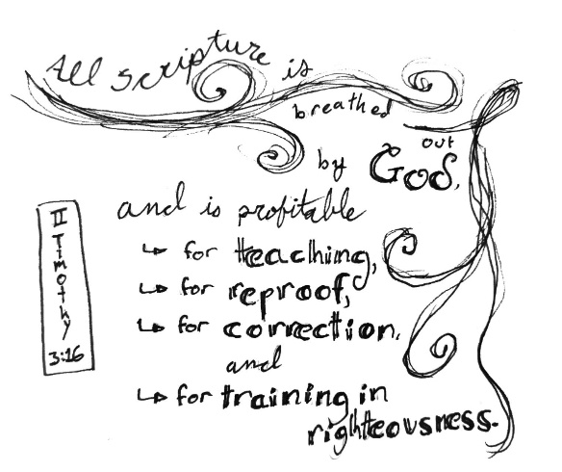
Key verse:
Often a text contains a verse that can summarize the central message of the passage. That's what we call a key verse. These verses are good to memorize because they can help us remember important lessons of the Bible, encourage us, or can be useful in sharing about our faith with others. Today's key verse is one of the most important verses in the Bible. It is well worth memorizing!
“All Scripture is breathed out by God and profitable for teaching, for reproof, for correction, and for training in righteousness.” – 2 Timothy 3:16
Conclusion:
The main questions of this lesson were: Why and how do we have the Bible? What is the reason or purpose behind us having the Bible? Having read and studied today’s passage, we can say that we have Scripture through God inspiring human writers to write His words, and we can trust it because we can trust God. We have the Bible so that we can grow as followers of Christ, being equipped to so by learning truth and learning how to tell what is false, and by applying our beliefs to our behaviors so we can do what is right—and avoid what is wrong.
Weekly Challenges:
- Memorize the key verse.
- Read over the next lesson.
- Read the passages for next week (Isaiah 42:1-9 and Isaiah 44:13-20). If you want to get the full context of the passages, feel free to read the full chapters (Isaiah 42 and 44); but it’s not required reading.
- Practice finding references more easily. Try these verses: Psalm 119:11. Proverbs 1:5-8, John 1:1,14. When you find the verses, copy them down in a notebook. It would be a good idea to have a notebook for the discipleship process, so you can write down important things that the Lord will show you!

Lesson 3
God’s Purpose – Our Salvation
Main Text: Isaiah 42:1-9 and Isaiah 44:13-20
Key Verse: Isaiah 42:6c
“I will give you as a covenant for the people, a light for the nations.”

Review:
In the previous lesson, we learned about how the Bible works, and how it applies to our lives as Christians. Can you list one of the ways the Bible could be used? What are the two main divisions of the Bible?

Introduction
First, Isaiah was a prophet. In the Old Testament, prophets were those who had been set apart by the God of Creation to be His voice to the world, to convey His messages to His people. Through Isaiah, God declared that a change was coming, and began preparing people for the transition from Old to New Testament. He told Israel how the covenant between them and God would change, and prepared the faithful to recognize Jesus when He arrived. Through Isaiah, God offered a message of hope and renewal in the midst of destruction and desperation. Through him, too, we gain further understanding of God’s purpose throughout history, and the love with which He planned to save the world.
So, having understood more of the context, it’s time to focus on the passage itself, starting with the question: who is the Servant?
Studying the Word
I. The Servant
One important tool used in Bible Study is the introduction, or conclusion. Basically, this is a verse at either the beginning (or the end) of a passage which more or less summarizes that Scripture, pointing out the message and/or important points succinctly. Sometimes this is the key verse, sometimes it isn’t.
With Isaiah 42:1-9, we find our introduction in verse 1. Having found it, what can we learn?

From this introduction we know that the message will be about the servant. The first word, “behold”, is a mechanism to grab our attention, to tell us to pay attention to what the Word is about to say. And we are told to “behold my servant,” the servant of the Lord. So, again, who is this servant and why is our attention being called to him?
Looking at the larger Biblical context, this passage is also quoted in other parts of the Bible to refer to Jesus (for example, Matthew 12:15-21), and in other places we see this prophecy being carried out in Jesus’ life (He cures the blind, God rests His Spirit upon Him, etc.). Jesus is The Servant of God. He is the “Messiah,” the “chosen one,” the coming Christ who was prophesied about for centuries.

This is the new thing being announced by the Lord (verse 9). This passage was preparing the people for the message of the New Testament, for Jesus.
II. Justice
One of the next points we find in Isaiah 42:1 is that the servant has the “Spirit of the Lord upon him.”
Let’s ask some questions so that we understand what the Lord is saying. What is the Spirit of the Lord?

What does it mean that the Servant has the Spirit of the Lord upon Him?

Why has the Servant come? Or What is His purpose?

Let’s dig a little deeper into the servant’s purpose. The word “justice” is repeated 3 times in 4 verses (Isaiah 42:1-4), and all three times the term is used in connection with what the Servant is doing. But how does God plan to bring about this justice?

What does justice mean here?
In looking for answers, we find out what justice is by what the Servant does, and in the kind of kingdom that He promises to establish. We see the results of it in Isaiah 42:6-7, in how He will open the eyes of the blind, free prisoners, and bring to the light those who sit in darkness.
This idea of justice is based on a promise of a just world or kingdom to live in, more than simply punishing wrongdoing. A just society would be full of mercy and peace, where people can live in dignity and grace, expecting kindness instead of cruelty. The idea of justice set up in verses 1-4, a justice to be established throughout the world, is a vision that would enable and support the merciful actions of verses 5-9.
What is justice, then? It is deliverance for those who are oppressed; it is saving grace for those who are under judgement; it is hope for those who have only known darkness in this life. Divine justice seeks restoration of life and honor and virtue for all mankind.
Isn’t that a great purpose for the Servant to have? Furthermore, the Servant being God’s Chosen One shows us what God values, as well—justice, mercy, love, kindness. Furthermore, all of this echoes what we learned in the first lesson, in Acts 17:31, where Jesus is described as someone appointed by God to judge the world, and who will do so in righteousness.

III. The God of Creation
Now we’ll be moving away from the points outlined in the introduction to take a closer look at what all of this shows us about the God of Creation.
God is directly involved throughout the passage—three times the Lord tells us that He is speaking, that He is acting (verses 42:5, 6 and 8). In vs. 5, God speaks, specifying who He is. In vs. 6, He calls the Servant, takes Him by the hand, forges a covenant, and gives light to the world (both through the Servant). In vs. 8, He states that He is declaring new things, and doing so before they happen.
A. Only One God
But we also want to know which God is this? Are there not many gods? In verse 6, God states that He is, “God, the Lord, who created the heavens and stretched them out, who spread out the earth and what comes from it, who gives breath to the people on it and spirit to those who walk in it.” He is the God who creates and was never created. This is the God of the Bible, the God of Christianity…the God above all.

Furthermore, in Isaiah 44:6 He says, “I am the first and I am the last, besides me there is no god.” What does this mean? How can we understand this? Let us be careful. Let us also listen to God the creator, who has knowledge beyond us, who has authority to speak as the one who made all things. There are spiritual beings. But in God’s category, there is only one. There are other spiritual beings, some more demonic, some more angelic, but there is only one God. To be God is to NOT be created. All things created are not God. He makes a distinction.
In Hinduism there are many gods. But their own stories tell of how they were created or procreated, therefore they had a beginning. But just like in the Greek culture, there is a God who created all things, from which all things came. In Hinduism there are also many levels of spiritual beings, from gods and demi-gods to man and to animals. In Buddhism there is a great spiritual leader, but he also was created. The God of creation says there is only one God. These are His terms. He has the right to define them. The God that created all things can make this distinction.
B. Gods of Gold, Silver, and Stone
Let us also note that the God of creation says in verse 8, “my glory I give to no other, nor my praise to carved idols.” What does this mean? The truth is that He is the God who created all things, including us. He says in verse 8 that it is not right to give His glory to others, to statues or to images.

Why is that? Let’s remember, from the first lesson, what the Word of the Lord said in relation to worship - that God doesn’t need our food, our service, nor does He live in our temples. This is not good thinking, not what He, the God of creation wants.

What does the God of creation want, if not food or flowers or to serve him in a temple? He wants us to seek Him, to seek Him in prayer, to seek Him in His word, the Bible, to serve Him in other ways.

C. God of the Future
There is one more important quality of the God of Creation that we see in this passage. The Lord declares in verse 9 that, “Behold, the former things have come to pass, and new things I now declare, before they spring forth, I tell you of them.”

The one true God, the God of creation, knows the future. He challenges the false gods in Isaiah 44:7, “Let them declare what is to come, and what will happen.” And then He responds, “have I not told you from of old and declared it (about the coming Messiah, Jesus)? And you are my witnesses! Is there a God besides me?”

In Isaiah there are many places where the Lord, through the prophet, talks about the coming Messiah. In places it is told with such detail what would happen in Jesus’ life and ministry, that there could be no doubt. For those who were not Christians, who did not believe in God, there was only one conclusion – Isaiah had to be written after Jesus’ death, it is too exact and clear a description.

These non-Christian historians and archeologists openly declared that Isaiah was written after Jesus death and that it was written to falsely present itself as written before Jesus. Isaiah had to be written after Jesus, they said. “Because if it were written before, it would be a miracle, and we do not believe in miracles,” they boldly stated.
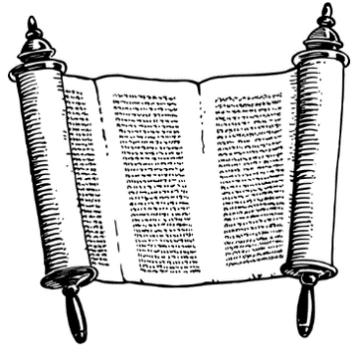
In the Lord’s justice and timing, soon after these statements, in 1946, a copy of the book of Isaiah (and other parts of the Bible) was found in a cave in Israel that was conclusively dated to have been written more than a hundred years before Jesus birth. According to the historian’s own words, this meant that a miracle had been proven. The true God can tell us what will happen. The true God is the creator of all things. The true God is not far, He gave us His word to show us the way and He sent his Servant to be the way. That is the message of the New Testament. In other discipleship lessons, we will learn more about how to worship and live for Him.

Conclusion
So, to sum up, today we learned about the prophet Isaiah, the Servant of the Lord and His purpose, how this reveals God to us, and what that revelation shows us about His character.
The God of Creation is teaching us, revealing Himself through His Word. He gave us His Word to show us the way—and He sent His Servant to be that way. He desires justice and mercy, and has the power to establish it; He knows the future and works in it. The Lord wants to free us from lies, meaningless worship, and aimless living; He invites us to instead participate in His truth, His coming kingdom, and His purpose. Let us continue to seek Him!

Activity: Creative Key Verse. Here is an example but create your own.

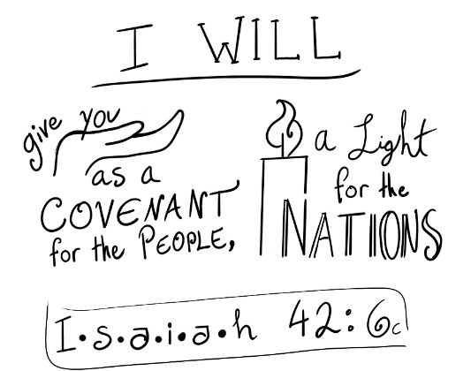

Next Week:
- Read the Bible passage for next week (Isaiah 44:13-20); pray for understanding and spend some time studying it. We will further examine the topic of worship as it relates to God versus other gods.
- Memorize the key verse from this lesson, Is. 42:6c. It is also recommended that you try to write/draw out other creative key verses, too. Maybe use a verse from the upcoming lesson.
- Bring a question or concern to the Lord in prayer, something you’ve been struggling with, and try to do it in confidence and trust—we know God cares for us immensely, and is immensely powerful, but it can still be intimidating if you haven’t practiced! After that, tell Him about something small that happened during your day. He already knows, but it can be an important part of learning to talk to God—and besides, He likes hearing from us in the small things, too. Try to also spend some time thanking Him for something He has done and praising Him for Who He is.

Lesson 4 – Activity
Discussion: Why Not Idols?
Text: Isaiah 44:13-20
Key Verse: Isaiah 44:17a
“And the rest of it he makes into a god, his idol, and falls down to it and worships it.”
Review:
Did you have any questions or observations that you would like to share from your reading of Is. 44:13-20?
Introduction:
In the last lesson we studied Isaiah 42:1-9, learning about God’s Servant, the kingdom He plans to establish, and what the passage could teach us about God’s character. This lesson is more relaxed in format and tone, focused primarily on discussion and reflection. Take whatever time is needed to consider and converse.
Discussion Questions
Why do you think people seek idols?

What is the advantage of having an idol, or a picture, in front of you?

What was your experience with worshipping gods, or other supernatural forces? What about idols, either literal or metaphorical?

Do you have any tangible experience of these gods/forces/idols coming to your rescue, hearing you, speaking to you? How have these idols impacted your life?

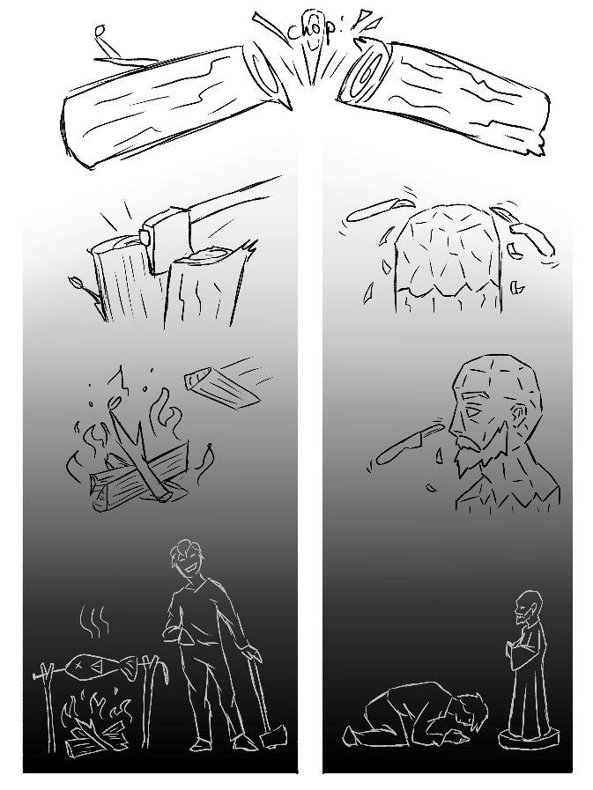
In Is. 44:13-20, the process of making an idol is explained. When you read that, what came to your mind?

Which part of the text corresponds to which part of the illustration? How do you think the illustration captures the ideas of the scripture? Does it correlate with your own experience or things you have seen?

Why do you think God did not want us to carve an image and worship that?

Have you ever worked on something that ended up being a waste of time, not worthwhile? How did it make you feel? What happened with it/what did you do with it?

What has God promised to do in Isaiah 42:1-9, and what have idols here promised to do? What are the promises that gods/idols make? What has God done? What have idols/gods done?
Do you think the verse about eating ashes (Is. 44:20) is an accurate depiction of the truth of worshipping idols? Why or why not?

Do you think worship should come from love, gratitude, and/or joy? Or perhaps it should come from duty, routine, and/or ritual? Why or why not? Would you say rituals are a comfortable form of worship? Why or why not?

If you look at all the images of the gods in the pantheon of the Hindu religion, what is the common characteristic of those images?

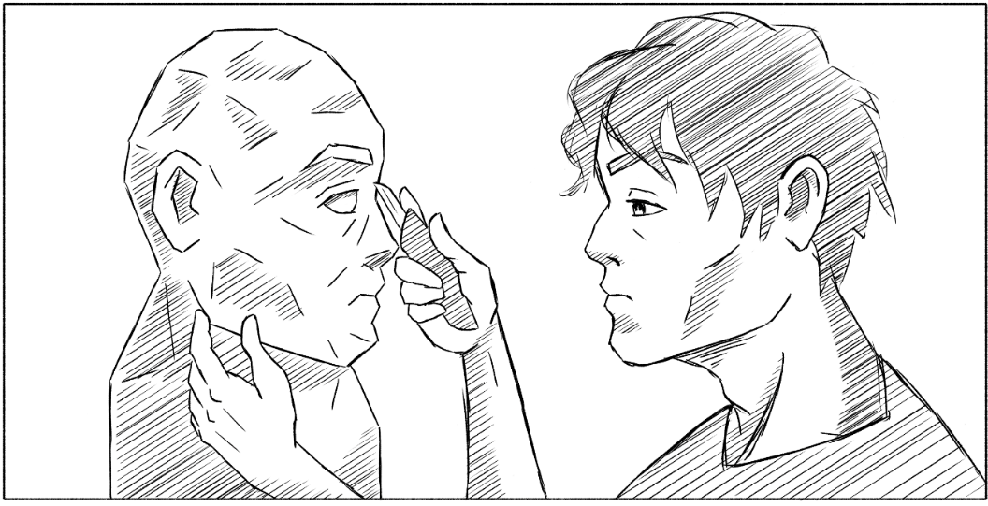
What does that tell us?
Is there a god that you know you can trust? Is there one that will protect you from the others?
No other god has been known to love. Yes, there is a god of romance, etc. But we do not know of any god that loves human beings enough to die for them. Some say that is to be expected; gods have their own lives to live, and so do we—why should we expect them to care about beings so removed from their plane of reality? But the Creator God is different. He created the world, and He created humans, and He did so out of love. Now that we have turned away from the blessings He meant for us, He seeks to bring us back, to bring us into a new fullness and a new place in His kingdom, to lift us to a higher plane of reality than we can imagine from our perspective in time and space. Isaiah 42:6 and 7 show us that the Lord Jesus come to bless, to save, to free from prison, to bring captives from darkness into the light. What motivates all this is His love for mankind, His children made in His image.
Some people say that the benefits of worshipping a god you can see and physically interact with (through images/idols, statues, special places, rituals) outweigh the risks of rejecting the True God that you cannot see. What do you think?
What is an experience that has drawn you to God? Why are you trying to learn more about Him?
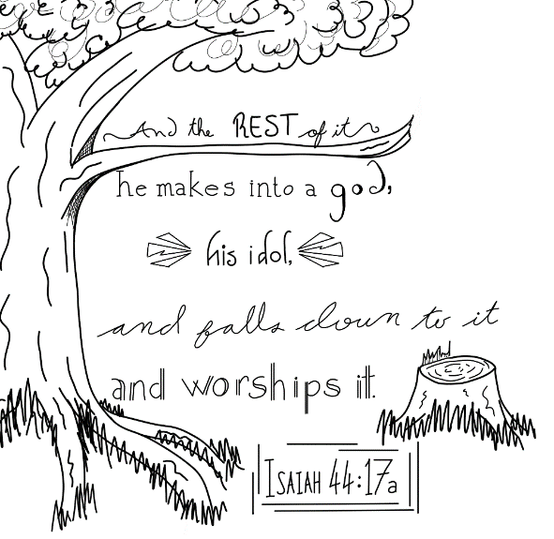
Is learning about Him and growing in your relationship with Him more important to you than idols? Why or why not?
Key Verse:
The key verse for this week is Isaiah 44:17a.

Conclusion:
God, the One who created the heavens and the earth, says that only He is God, that it is wrong to worship others. We should not worship any other spiritual being, however good, powerful, or impressive. Why is that? Well, God, the Creator, gave them that power, designed them to be who they are. God created them with purpose and with value—though some have broken faith with Him, twisting that purpose and falling into darkness. But no matter how powerful they are, they are not God, and they cannot save. Maybe for a while they can “protect” us, physically, but they cannot free us from sin, they cannot keep us from hell, they cannot save us in any way that truly matters. When we appease or negotiate with other spiritual beings (“gods,” demons, or even angels), by our actions we are refusing to trust in God, and are turning away from our Creator.
We can respect others. We can, and should, remember those who have passed away, for example, and be grateful for their teaching and influence. But to bow down and worship another person or created being, dead or alive, is the wrong way to show this appreciation.
So, what is Christian worship? It is embracing God’s purpose and plan for our lives, and for our society. Worship is to recognize Him for who He is, and accept that only He can save and forgive sins. It is to serve Him and obey Him and His commandments; to study His word for knowledge of Him and for instruction; to pray to Him and form a relationship with Him and seek to know Him; to love and care for His creation without mistaking it as anything more than a shadow of His glory and creativity.
No other god has been known to love. Yes, there is a god of romance, etc. But we do not know of any god that loves human beings enough to die for them. Some say that is to be expected; gods have their own lives to live, and so do we—why should we expect them to care about beings so removed from their plane of reality? But the Creator God is different. He created the world, and He created humans, and He did so out of love. Now that we have turned away from the blessings He meant for us, He seeks to bring us back, to bring us into a new fullness and a new place in His kingdom, to lift us to a higher plane of reality than we can imagine from our perspective in time and space. Isaiah 42:6 and 7 show us that the Lord Jesus come to bless, to save, to free from prison, to bring captives from darkness into the light. What motivates all this is His love for mankind, His children made in His image.

Next Week:
- Prepare for the next lesson by reading over it, and the scripture passage it studies (Matthew 6:5-8). Be sure to write down any thoughts or questions.
- Spend some time thinking and praying about any questions, doubts, or concerns that stood out to you from this lesson. Perhaps you could write them down, documenting the questions and any answers you might find. If doubts or questions persist, try to seek out someone from the church to help you work through those (your discipler, or your pastor, or someone else trustworthy).

Lesson 5
How to Pray
Text: Matthew 6:5-8
Key Verse: Matthew 6:6a
“But when you pray, go into your room and shut the door and pray to your Father who is in secret.”

Introduction:
Today we are going to talk about something vital to the life of a believer: prayer. It is our connection with our Lord, and it is something that anyone can do—nothing prevents us from talking to our Savior! There are many ways to approach prayer, however. By studying today’s text, let's take a deeper look at what prayer is and what it is not.
Open your Bible to Matthew 6:5-8.
Discussion Questions:
The text tells us what kind of person we should not be like when we are praying. What kind of person is that? Why not? What is the reward of those people? (vs. 5)
Is verse 6a saying that every time you pray, you need to literally go into your room and shut the door? Explain what you think this verse means.

What does it mean to pray with “empty phrases," or “vain repetitions,” as some versions say? (vs. 7)

What do you think it means when the text says that "they think that they will be heard for their many words"? (vs. 7)

God already knows everything we need before we speak (vs. 8). So what is the purpose of praying to Him, and asking for help or counsel? Doesn't He know everything? Why doesn't He just help us?
What Is Prayer?
This is both simple and difficult to answer, since there are many ways of praying and talking to our Father. So, in an attempt to get a clearer picture, let's start with what prayer is not. There are many examples, but let's look at two:
1) The first is when a person has memorized a prayer and uses only this prayer and repeats it until the words no longer have meaning, speaking it because it is a prayer and not because they believe what it says.
2) The second is when a person prays for a long time, but never actually says anything meaningful. These prayers may be pretty words, but they don’t reflect their personal life. For example, this person prays at length for more people to come to Sunday school and that the church would grow, but this is the first time they’ve come to church in months, and they never share with others about their faith.
Prayer is not a performance to show people. It is also not simply saying things as if the words were a magic formula.
- So, what is prayer? The purpose of prayer is to create and deepen our relationship with God. It is for our benefit, it is a lifeline, it is a direct connection with the Lord, and it nourishes spiritual growth.
- How can I pray? It's like scripture says—go into your room or a private place and talk to God. There is no specific position or formula that must be conformed to.
- How can I avoid “empty phrases”? Speak frankly, remembering that the prayer in and of itself isn’t power—instead, the power comes from our Father who always hears our prayers. Also remember that your prayers are for God to hear, not for the people around you to think more highly of you. That being said, there is nothing wrong with making your prayers more elaborate! Just make sure that the motivation is more to create something beautiful to praise God, and not to impress other people or make yourself feel more spiritual.
- What can I pray about? You can pray about anything and everything! It's a conversation with God. Every activity in your life, every problem or concern, can all be brought to Him. The fundamental purpose of prayer is not to convince the Lord to do things, but to grow our relationship with Him. So, while you should be respectful, you can speak to Him as you would a close family member.
In a later book, we will look at Jesus’ example and how He prayed and how He taught his disciples to pray.
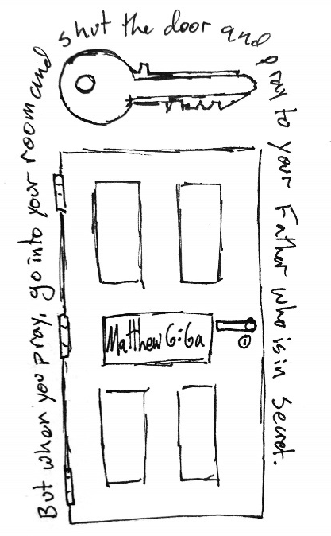
Our key verse for today is found in Matthew 6:6a: "But when you pray, go into your room and shut the door and pray to your Father who is in secret."
Another example of how to draw in a creative way can be seen on the right:
Weekly Challenge:
- Your challenge for next week: Separate five minutes each day for prayer. If you don't know what to pray about, you and the discipler can make a list of prayer requests together. Focus not just on physical needs but spiritual needs as well. And just talking with God!
Some quotes about prayer:
“I pray because I can't help myself. I pray because I'm helpless. I pray because the need flows out of me all the time, waking and sleeping. It doesn't change God. It changes me.” – C.S. Lewis
“To be a Christian without prayer is no more possible that to be alive without breathing.” — Martin Luther
Lesson 6
Introduction to Discipleship
Text: Psalm 1
Key Verse: Psalm 1:2
"But his delight is in the law of the LORD, and on his law he meditates day and night.”
Introduction:
Today we will look at how to grow in our faith and how to walk in the paths of the Lord. We call this the process of discipleship. As Jesus discipled, we are also called to disciple others. In fact, these little booklets have been designed to help with that process, encouraging your growth in Christ, and eventually leading you to help others in that same growth.
Today's text comes from the Old Testament, in the book of Psalms. The book of Psalms is part of the “Wisdom Literature,” a section of the Bible comprised of five books of poetry. These are found in the middle of the Bible, and include Job, Psalms, Proverbs, Ecclesiastes, and the Song of Solomon. Our church uses Psalm 1 as the basis of our discipleship books, especially verse 3: “He is like a tree planted by streams of water that yields its fruit in its season, and its leaf does not wither. In all that he does, he prospers.”


First Steps Growing Our History Our Mission: What will be
in Christianity in Christ! and Beliefs Multiplication My Ministry?
You can see the images of a tree being planted, and how it grows. Using this as an example, we will also mention an important characteristic from the poetry in the Bible. In the poetic books, and especially the books of Psalms and Proverbs, the Spirit uses comparisons to communicate. Some of the comparisons deal with the similarities between things. We see this in Psalm 1:3, where the righteous person is compared to a tree, "He is like a tree planted by streams of water..."
Also, in Psalm 1 we can see another kind of comparison—contrast. Throughout the whole psalm we see the contrast and differences between the righteous and the wicked.
It’s always important to pay attention to the images being used in the psalms! Let's get started!
Conversation Questions:
- Have you ever seen people trying to pursue their own happiness, and then fail?
- Where do you find “delight"?
- What does it mean to be blessed?
- What do you think the text means when you say that the righteous meditates "day and night"?
- How can we meditate on the law of the Lord?
- What has your devotional life been like?
- What books have you read from your Bible? Do you read your Bible often?
- What is your favorite book/verse/story of the Bible, and why?

Discussion Questions:
What shouldn’t we do? Why not? (vs. 1)

Where is the delight of the righteous person? When and how does he meditate on the law of the Lord'? (vs. 2)

How is the righteous like a tree? What are the qualities listed? (vs. 3)


What are the wicked like? What are the differences—the contrasts—between the righteous and the wicked? (vs. 4)

The text says "therefore." What will happen as a result of these differences? (vs. 5)

What are the two paths, and what is the difference between them? (vs. 6)

This psalm teaches us about the effect that the Bible has on us. When we listen to God's teaching, it will help us to be "like a tree planted by streams of water that yields fruit,” and so much more. A contrast is also placed firmly between the sinner and the righteous—one is "blessed,” the other is forsaken. The path of the wicked is fleeting, and what he does won’t last. The path that the Lord offers provides continuous growth, giving us strength each day to overcome the difficulties of life. He offers us life, and life in abundance. (John 10:10)
Something that can be difficult as a new convert is to leave the familiar places of the past, like those we saw in verse 1—the counsel of the wicked, the way of sinners, and the seat of mockers. The new convert will remember places and friends of the past that were not good, but are familiar and even comfortable. Are there places like this that you should avoid? Are there places that tempt you, or that you still like to go, but aren’t appropriate for you now that you’re a Christian? What about friends who want you to continue in your old ways?
Let’s consider how to walk in the way of the Lord. First, there are places that are healthy, uplifting, and beneficial for a righteous person. What would these places be? Do you have any doubts about certain places or situations, or do you need advice on how to deal with these?
How do we walk in the way of the Lord? The answer can be found in verse 2, which says that "on His law he meditates day and night." Does this mean that we should always be reading the Bible, every hour of every day? No—that would make it almost impossible to do anything else. But meditating on the Word is different. When we say "meditate," we're not talking about the common idea of meditating, which says to sit with your legs crossed, take a deep breath, clear your mind, that kind of thing. Rather the idea is more to “contemplate” the Word, because instead of clearing our minds we are filling them with the Word of God. The Word of God must always feed our minds, enriching our thoughts and changing our attitudes. In later lessons, we will devote more time to discovering new ways to delve into the scriptures and learn to understand and practice it, but for now, the most important part is getting to know the Word. One way to do this is through memorizing verses.
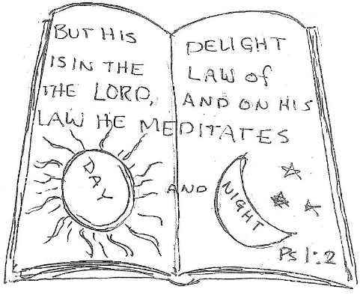
Today we will memorize Psalm 1:2, but here is a challenge: to memorize all of Psalm 1 before finishing this booklet. This will be worth a prize at the end of the book!
Key Verse: "But his delight is in the law of the LORD, and on his law he meditates day and night.” — Psalm 1:2
Weekly Challenge:
- Read one chapter of the Bible a day and ask a few questions about the text, then answer them afterwards. You can write the questions and answers in your devotional notebook, or do them mentally if you prefer! These can be simple, based on questions like: Who? What? Where? When? How? and Why? You don’t have to have all the answers, either! You can bring them to the discipler or your pastor for more input.
Activity: Make an acrostic with the word "tree," placing a word or idea for each letter that begins with that same letter, something that reveals a quality of the righteous, or of walking with God. For example:
Two ways. Rejects the counsel of the wicked. Eternal. Enjoys the Word of the Lord
Lesson 7
Temptation
Main Text: James 1:12-15
Key Verse: James 1:12a
"Blessed is the man who remains steadfast under trial."
Introduction:
Today we will learn about temptation, what it is, the danger it presents, and how to resist it. Temptation comes in many forms, but one of the most dangerous aspects of temptation is that it comes from our desires. Since it is something that we want, it makes it harder for us to resist it. To learn more about this topic, let's open the Bible to James 1:12-15.
Conversation Questions:
- What do you think is temptation?
- What do you know about perseverance?
- What is sin?
- Why do we sometimes want to do what we know is wrong?
- Try to remember a time when you were tempted. Were you able to resist it? Do you know why or why not?
- Are you currently facing temptation?
- What do you consider to be your most vulnerable area, as far as desire/temptation is concerned?
- Have you ever seen people blaming God for their difficulties? Why do you think they acted like that? Do you think they were right?
Discussion Questions:
Why is the man mentioned here considered to be blessed? We are called to “remain steadfast” against what? (vs. 12)

To whom will the crown of life be given? (vs. 12)

What are we not to say when we are being tempted? Why is that? (vs. 13)

Everyone is tempted by what? When does it happen? (vs. 14)


How does ‘desire’ develop? What does following these desires lead us to? (vs. 15)

It sounds very simple, right? But what is temptation? Something you want? Yes, but is there anything else? The answer to this question can be complicated because it has many ways of showing itself, depending on the person. To get a more solid idea of what temptations can look like, let's examine a few types of temptation.

Basically, there are three types of temptation: materialism, hedonism and egotism. Materialism deals with desire for material things, like a new car; hedonism is about the desire to have pleasures of different kinds, including sexual pleasure; egotism deals with pride and our desire to be praised, or to be better than others.
Most of these things are not bad in and of themselves, but there is right time for everything. Moderation is also important, as well as how you try to get these things. Having a good car is not bad—stealing money to buy the car is bad, or wanting to have five cars simply to show everyone that you’re rich, or if the car becomes the most important thing in your life to you.
This lesson is to teach about what temptation is, but also about how to resist it. The key to doing so is in verse 12, and it is something simple (but very difficult to practice): we must endure with perseverance. We can pray and ask for God's help (and He will help us!), but in the end, it is us who will decide whether or not we will do or pursue something sinful.
Some tips to do help us remain steadfast:

First, take care to avoid temptation. If you know you will be put in a situation where you will be vulnerable to temptation, flee! If you are trying to avoid drinking alcohol, do not enter a place where they serve drinks, such as a bar. It is wise to avoid even going near such places, if possible, since even just looking can tempt you.
Second, don’t give a lot of time or thought to the temptations that appear. Temptations come up. Desires appear, sometimes strongly and suddenly. But we can decide whether or not we're going to spend a lot of time contemplating them or not. The more time we spend thinking about it, the more likely we are to act according to this temptation.
Third, try to find something to occupy your mind in the place of the temptation. If you're thinking too much about something you shouldn’t, seek out something else that will occupy your mind and take focus off that desire. Reading the Bible and praying is always a good idea, however it can also be something like a hobby you enjoy (drawing, sewing, gardening, etc.).
Fourth, find someone that you trust to keep you accountable, to ask you questions about what is going on, and to pray with you and for you.
Fifth, remain steadfast. Don't stop resisting. Sometimes it seems like a temptation will never go away, that we will always be suffering from it and fighting against it—but that is neither a reason nor a justification to give up. Endure and persevere until the Lord frees us. Perseverance is also important for something else: for when we fail. Building new habits will take time, and is difficult. We would rather be cured all at once, but most of the time, healing is a long process. We will always hope that we can easily resist temptation, but the truth is, we are going to fail sometimes.
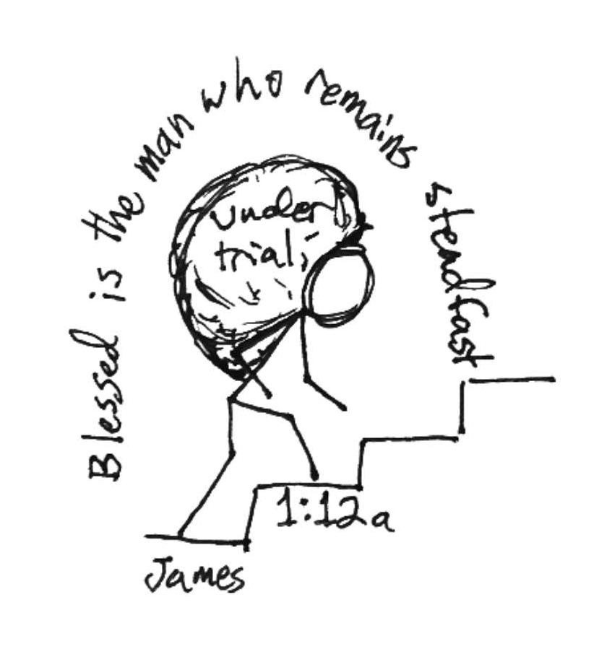
Perseverance is an important quality that will help you continue despite the failures. Perseverance will help you stand up time and time again, even when it would be easier to give up. But the Lord has grace to cover our faults! There is nothing that we can do to make the Lord to refuse to forgive us.
Key Verse: "Blessed is the man who remains steadfast under trial." — James 1:12a
This week:
- Make a list of your strongest temptations right now, and start creating a plan for how to avoid falling to them. Remember, it doesn't have to be a huge change, or something that takes place all at once! If you can do that, great, but if you can't, it's okay. It is fine (and normal, even) to take this journey one step at a time. The Lord has all the patience necessary to help us, and He Himself walks with us.
- Also, work on the verses and make sure you have them well memorized. And don't forget the challenge of memorizing Psalm 1!
- Continue reading a chapter of the Bible and praying every day.
A Time and a Reason to Sing – “The Doxology”

​For Christians, there is a rich heritage of music since the very beginning. God’s people sing! For this reason we have the book of Psalms in the Bible, which is a collection of songs and poetry. They serve to encourage and focus our faith on the eternal truths of Scripture. They unify God’s people around the world since the doxology and many other hymns have been translated into almost every language that exists. The hymns are considered an essential element in the worship and fellowship of the church.
The Doxology is one of the most widely known hymns of all time. ​​​Written in 1674 by Thomas Ken, it is often sung as a call to worship and it celebrated across almost all denominations. Some use it as a prayer.

Praise God, from whom all blessings flow;
Praise Him, all creatures here below;
Praise Him above, ye heav'nly host;
Praise Father, Son, and Holy Ghost.
Amen.

Discipleship Material
Transcultural – Global - Adaptable

5 Books that form a plan of discipleship,
and prepare people to serve the Lord.

First Steps Growing in Our History Our Mission - Which Will Be
In Christianity Christ! and Beliefs Multiplication My Ministry?

Unless otherwise indicated, all the Scriptures that are quoted in English
will be from the ESV version of the Bible

Please adapt and translate this material for your needs. Also use the QR Code or link below, to evaluate the material and inform us how it is being used. The purpose is merely to have feedback about the material and to help us with any errors that we may have missed. There are no copyrights or restrictions in the use of this material. All glory is given to God for this project. Go, make disciples of all nations! Blessings.


Discipleship Material Evaluation Form



The Wesleyan Workshop

wesleyanchurchlk@gmail.com

In the Bible, when we see the phrase “the Lord,” (with the “L” capitalized), or sometimes “the LORD,” (with the whole word capitalized), it is referring to the Creator God. It isn’t talking about a lord, it is talking about the Lord, Lord over all the earth, God above all.

