





O UR HISTORY
He is like a tree planted by streams of water that yields its fruit in its season, and its leaf does not wither. In all that he does, he prospers. Psalm 1:3
3rd Book
D I S C I P L E S H I P Series

AND BELIEFS

The Members Manual

Our History
- Wesley, England, and USA p. 1
- The Wesleyan Church up to the Present p. 6
Our Theology
- The Trinity and Humankind p. 15
- Salvation and Sanctification p. 19
- Last Things and the Church p. 24
Our Commitments as Members
- God, You and the Family p. 28
- The Church and Others p. 31
- Suggestions for the Christian Life p. 34
- Membership and Leadership p. 36
- Baptism p. 40

Lesson Number 1- History I: From John Wesley to the Wesleyan Methodist Church
The Rise of the Wesleyan Movement
1. The Wesleyan movement was centered on scriptural truth with respect to the doctrine and experience of holiness, which declares that reconciliation in Christ provides not only the regeneration of sinners, but also the entire sanctification of believers. The revival of these biblical truths with respect to Christian perfection and biblical holiness occurred under the leadership of John Wesley in the 18th century, and continues, in various forms, to the present.
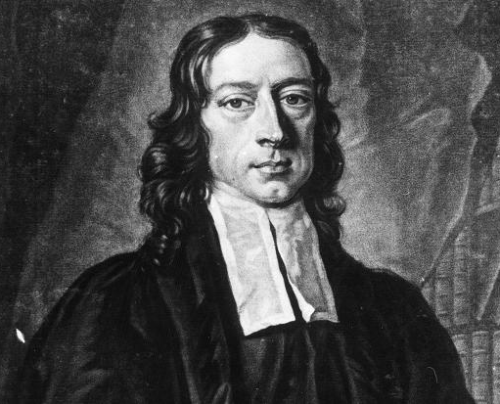
2. Having been raised in a godly home, John Wesley devoted himself to seeking God from an early age. While studying at Oxford University, along with his brother Charles and a few other serious-thinking students, he methodically sought holiness through systematic Bible study, prayer, good works, intensive self-examination, and selflessness. The group earned the nicknames "Holiness Club" and "Methodists", but Wesley did not yet have the certainty of salvation. Having graduated from Oxford and having been ordained as a minister in the state church, he intensified his pursuit of peace through legalism and self-discipline. The change occurred in a prayer meeting at Aldersgate Street in London on May 24, 1738, when he perceived the way of faith and felt his heart “strangely warmed” by the new birth. As he went on to the experience of entire sanctification, he shared with others his testimony and teaching, and a spiritual awakening spread throughout the British Isles, reaching America.
John Wesley
3. It was not Wesley's purpose to start a new church denomination, but the awakening caused the spontaneous birth of the "societies" that became the Methodist movement. Near the end of 1739, eight or ten people came to Wesley in London who were deeply convicted of their sin and sincerely longing for redemption. Two or three more people came the next day asking that Wesley spend some time with them in prayer and advise them how to flee from the coming wrath, which weighed on their hearts continuously. It was planned that one day a week, on Thursday night, they would meet. For these people, and as many as wished to join them (for their numbers increased daily), Wesley gave counsel that he judged most necessary for them, and always concluded their meeting with prayer. The Commitments of Membership found in this Handbook (260-268) represent, in revised form, those counsels that Wesley gave to members of societies to enable them to test the sincerity of their purpose and to guide them in holy living.
John Wesley
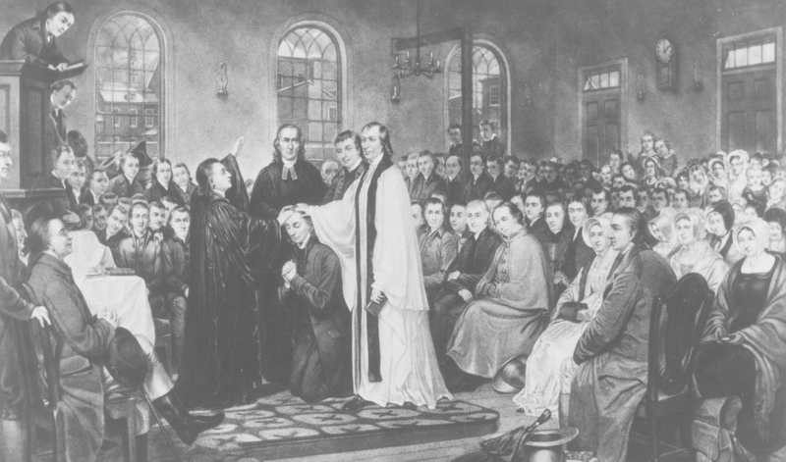
4. The movement spread to America by the emigration of Methodists, who, in 1766, began organizing "classes" and "societies" of the Methodists in the American colonies. In December 1784, the Methodist Episcopal Church was organized at the Christmas Conference in Baltimore, Maryland. The new church grew miraculously, especially on the coast, and quickly became one of the largest religious forces in the new nation.
Christmas Conference - USA
The Ordination of Francis Asbury

B. The Wesleyan Methodist Connection Organization
6. John Wesley and America's first Methodist leaders were adamant in denouncing human slavery. But with the invention of the cotton-gin, the economic advantages of slavery involved many ministers and members of the Methodist Episcopal Church in slave ownership. When a group of ministers from the New England Conference, led by Orange Scott, began to fight once again for the abolition of slavery, bishops and others in the church sought to silence them so that the peace of the church would not be disturbed.
7. The inner conviction of truth provoked a confrontation with the ecclesiastical authority and led to a series of departures from the Methodist Episcopal Church. The states of Michigan, New England and New York were the first states to begin to leave. Important leaders who did not agree with slavery published the newspaper: The True Wesleyan. In the first issue was listed all of the reasons for leaving the church, and summoned others to do the same. In the formation of a new church there would be no episcopal government or slavery. As a result a new organization, called "Wesleyan Methodist Connection", emerged in 1843. A "connection" of local churches organized in annual assemblies which avoided the episcopal government and provided equal ministerial and lay representation in all its governing bodies. Moral and social reforms were strongly emphasized, prohibiting the possession of slaves and all involvement with intoxicating beverages.
8. The organizing convention of the Wesleyan Methodist Connection of America was held in Utica, New York, from May 31 to June 7, 1843.

C. The Revival of the Wesleyan Experience
11. The Wesleyan Methodist Connection saw the conclusion of the crusade against slavery in the Civil War. Later, many felt that there was no more reason for the Connection to continue as such and returned to the larger Methodist church. Others found, as expressed by the 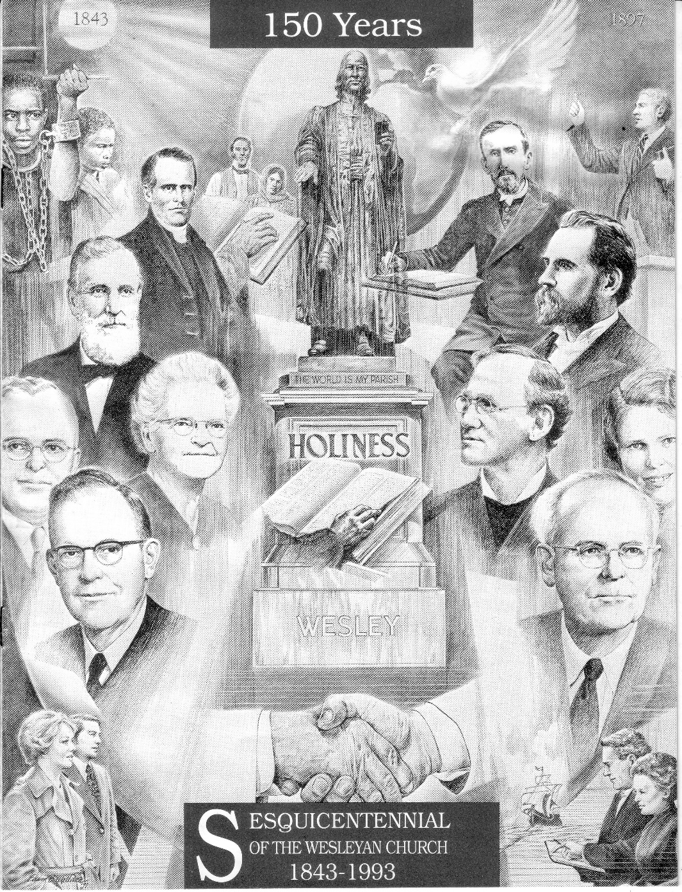 the General Assembly of 1867, that the effects of slavery still existed as was the allowance of alcoholic beverages. The need for the Connection still existed.
Celebration of 150 years of
1843-1993 Wesleyan Church

Seth Rees
Martin Wells Knapp
Branch - Wesleyan Methodist
Branch- Pilgrim Holiness
150 Years Old
Orange Scott

12. At its first General Conference in 1844, the Connection adopted an article of religion on "sanctification", becoming the first denomination to do so. But doctrine and experience suffered neglect and decline among all branches of Methodism in the mid-19th century. To renew them, God raised a revival of holiness promoted by literature, evangelistic meetings, and camps that stretched through all of Methodism and crossed over to other denominations. The revival induced the establishment of several new denominations emphasizing holiness, to the renewal and new orientation of others.
13. This spiritual revival, rigorously promoted by a group of itinerant evangelists, soon established the doctrine of holiness as the most important doctrine of the Wesleyan Methodist Connection, which once emphasized social and political reforms.

Questions to Deepen Understanding
1. What happened at a prayer meeting on Aldersgate Street in the city of London that initiated a spiritual awakening in the British Isles and spread to America? What was the date of this important event? (1.2)

2. It was not Wesley's purpose to begin a new church denomination, but the awakening led to the spontaneous beginning of the "societies”. Describe what these groups were like. (1.3)

3. What was the date of the beginning of the Methodist church in America, the Christmas Conference in the city of Baltimore and how was the progress of the new church? (1.4)

4. What was the date and reason for the organization of the Wesleyan Methodist Connection? (1.6 and 7)

5. At the first Connection conference, they included an article of religion that served and still serves as a distinction of the Wesleyan movement. What was it? (I.12)

6. This doctrine caused a spiritual revival in North America. Who promoted it? (I.13)

Lesson Number 2 History II: The Wesleyan Church up to Present
D. The Development of the Wesleyan Methodist Church
16. The revival that spread through the Wesleyan Methodist Connection introduced a new emphasis on evangelism. The need for an organized effort to extend the work and provide for the needs of new converts caused the gradual development of a more formal organization as a church rather than a connection. In 1891, the name was changed to the Wesleyan Methodist Connection (or Church) of America, and the denomination went from merely having a leadership to produce publications (editor and publisher) to elect a general superintendent. Other departmental executives were gradually added. In 1947, the name changed to The Wesleyan Methodist Church of America, and a central supervisory board was established with the general conference president as the full-time leader and the Board of Directors as the central and coordinating board.

E. The Formation and Development of the Pilgrim Holiness Church
23. The Pilgrim Holiness Church came into being because of the revival of scriptural holiness that spread throughout the various denominations in America in the last half of the 19th century, the same awakening that guided in a new direction the energies of the Wesleyan Methodist Connection from social and political reform to holiness evangelism (12-13). The awakening crystallized in the establishment of many non-denominational and interdenominational unions and holiness associations and independent churches. Near the end of the 19th century many of such precious faith began to draw together in the unity of the Spirit.
35. It remained an indelible characteristic of the original purpose of the founders of the Pilgrim Holiness Church such as Martin Wells Knapp and Seth Rees to promote world evangelism with an emphasis on holiness. Missionary work was carried on in many places,

F. The Formation of the Wesleyan Church
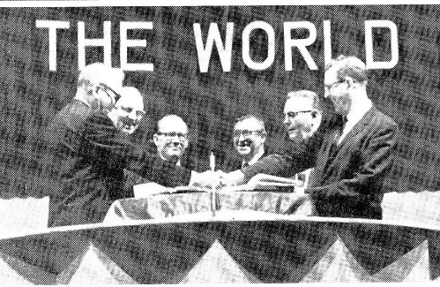
50. The merger between the Pilgrim Holiness Church and the Wesleyan Methodist Church of America was proposed several times and was brought to a vote by the General Conferences of the two groups in 1958 and 1959, not passing the Wesleyan Methodist General Conference by just one vote. In 1962, the General Conference of the Pilgrim Holiness Church expressed renewed interest in joining with the Wesleyan Methodist Church. In 1963, the General Conference of the Wesleyan Methodist Church acted similarly, instructing its Committee on Church Union to carry out its work with due diligence. On June 15, 1966, the Thirty-Second General Conference of the Wesleyan Methodist Church adopted the Basis for Merger and Constitution, and subsequently the annual conferences and local churches ratified the action. On June 16, 1966, the Twenty-fifth International Conference of the Pilgrim Holiness Church also adopted The Basis for Merger and Constitution. Thus, the formation of the Wesleyan Church was authorized. The General Board of the Pilgrim Holiness Church and the General Board of Administration of the Wesleyan Methodist Church cooperated in planning the uniting General Conference, and in preparing the new Manual for its consideration. On June 26, 1968, the Pilgrim Holiness Church and the Wesleyan Methodist Church of America came together, forming the Wesleyan Church.

G. The Development of the Church Outside of North America
As the Wesleyan Church developed in North America, the mission to reach all people with the Gospel did not grow cold. At the end of the 18th century both branches of what would become the Wesleyan Church engaged in missions. Although the two branches would become one church, they operated distinctive areas in missions and followed different procedures. This joining together would make for a stronger, more effective vision.
The Pilgrim Holiness Church reached their first mission field, Peru, South America, in 1892. They continued to send out missionaries and spread the Gospel, especially to the Caribbean, Latin America, Africa, and the Philippines.
In the Pilgrim Holiness Church, when the missionaries sensed a call, the church recognized this call and then the missionary chose the field where they felt led. They raised their own support among the churches and then they were sent out. The emphasis for mission work in the Pilgrim Wesleyan Church was on outreach. This including church planting, revivals, camp meetings and Bible Institutes.
Latin America is a good example of the work of the Pilgrim Holiness branch of the Wesleyan Church. The church in this area grew gradually until 1996 (after merging to become the Wesleyan Church). The Wesleyan church was in nine countries in Central and South America (Latin America). The Lord began to move through the hearts of the national leaders during a Latin American (LA) missions conference hosted in Puerto Rico. The call was strong to begin to reach the unreached countries in LA. In 2011 during the LA missions conference, it was announced by the Global Partners area director, Rick West, that through their efforts, the Wesleyan church was now in 24 countries in LA. From nine countries in 1996 to twenty-four in only fifteen years. This growth occurred because the missionary activity of LA missionaries, not North American (NA) missionaries. This revealed the strength of the work in LA and God’s anointing. Latin America has become a regional conference and is working to become a general conference, equal to NA, the Caribbean, and the Philippians.
The Wesleyan Methodist branch began their mission outreach two years after the Pilgrim Holiness branch had reached Peru. Their first work, in 1894, began across the globe in Chhattisgarh, India. Their desire to obey the great commission also led them to the Caribbean, Latin America, and Africa. But it also led them to further points east like Japan, New Guinea, Australia, Nepal, and Taiwan.
The Wesleyan Methodist branch of the Wesleyan Church organized itself differently. Funding was centralized and the NA church raised funds and sent out missionaries with a salary. The denomination chose where the missionary would go. The emphasis was on a wholistic ministry including schools, hospitals, and other social ministries.
Perhaps the best example of the ministry of the Wesleyan Methodist branch would be Sierra Leone. Begun in the early 1900’s, church planting was extremely difficult, but the faithfulness of the laborers eventually began to bear fruit. Besides churches, schools and a hospital were also established.
In 2008, the president, Dr. Ernest Bai Koroma, made a special video for our international conference to greet and thank our church for our important work and investment in the people and country of Sierra Leone. He received his education in a Wesleyan school and is currently a member of a Wesleyan church.
In 2014-2016 with the Ebola virus outbreak in West Africa, particularly in Liberia, Sierra Leone and Guinea, the Wesleyan hospital, the schools, and churches were instrumental in the containment and eradication of the disease. World Hope Intl came along side and offered needed aid in this crisis.
As of 2020 there are 228 churches in Sierre Leone, with a membership of over 30,000 people. There are 128 elementary schools and 27 high schools, with a combined total of almost 50,000 students. There are two Bible Institutes and a hospital with 110 beds.
The Wesleyan Church is and has always been a missionary church. And quite often, the Lord has used missions to revive and refocus the efforts of the church to obey the Great Commission. The Wesleyan Church is currently in ninety-nine countries of the 204 around the world. God continues to use the people of the Wesleyan Church to spread the Gospel and the message of holiness. All can be a part of God’s work to reach those who are in prison, who sit in darkness.
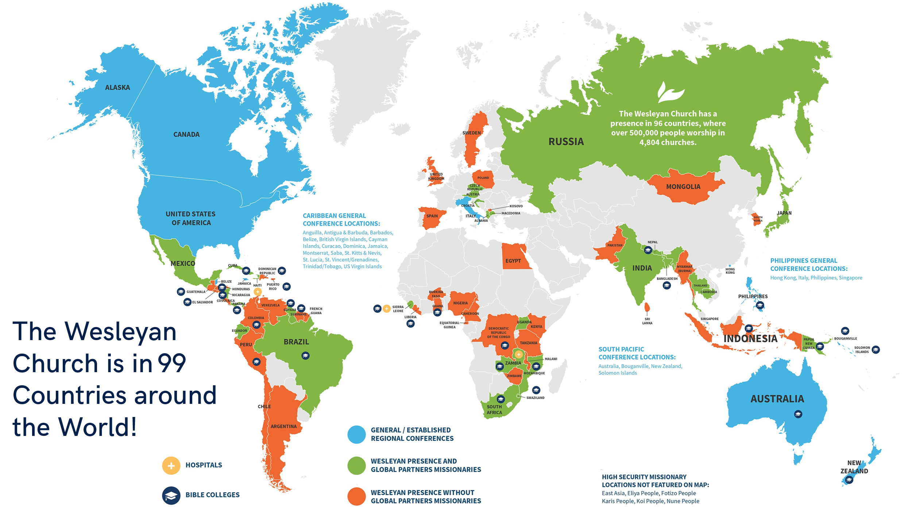

H. The Wesleyan Church in South Asia

For more than 125 years, God has been blessing and developing His church in South Asia. The Wesleyan Church started in the great country of India, as was mentioned in Rajnandgaon, Chhattisgarh in 1894. Churches were planted, a leprosy hospital built, and seven schools were established. Missionary doctor, Rebecca Bibbee served for decades in the leprosy hospital, caring for the least and the disadvantaged of India. There are currently 15 churches and over 1,200 members in Chhattisgarh. In 1904 the Wesleyan Church arrived in Gujarat and Vape became the headquarters. Rev. Linus Justin, a third generation Wesleyan, is the current leader. His grandfather helped to establish and develop the church in Gujarat. The work includes 25 churches, two elementary Schools and a high school.
After this early beginning in South Asia, it was 90 years before new works began for the Wesleyan Church in this part of the world. In 1991 Rev. Jang Bahadur in Pakistan began to seek partnership with the Wesleyan church, because of growing liberalism in denomination he was a part of. In 1994 the Wesleyan Church of Pakistan was made official with Rev. Eric Bahadur (son of Jang) in leadership, the only actor to found a Wesleyan Church! The fifty churches and elementary schools are under the national leadership of Rev. Patrick Bahadur.
As a young man Cedric Rodrigo of Sri Lanka sensed a call to serve the Lord. In 1993, after studying in Australia he returned to Sri Lanka, to start a Wesleyan work The church has experienced a steady growth with a strong emphasis on discipleship and preparation of leaders. There are strong leaders in the eight Wesleyan churches, with more being prepared. Today the work is poised for greater growth as the churches are in key areas around Sri Lanka (west, north and south), in both principal languages (Sinhala and Tamil).
In 1996 a group of churches in Northeast India united with the Wesleyan Church, because of growing doctrinal differences they were experiencing with the Methodist Church of India. The Wesleyan Methodist Church of East India (WMCEI) was born. WMCEI came with strong churches from two states, Manipur and Mizoram. These churches had strong mission work in other nearby states. In 2012 WMCEI became two districts – WMCEI and Mizoram. Both districts are strong, with each over 2,000 members. Mizoram has a close relationship with Myanmar because of the many Mizo (the same tribal group) in the country. Manipur, made up of the Hmar tribe, are active in reaching into neighboring states to share the Gospel of Jesus Christ.
In the late 1990’s, through the reading of John Wesley’s writings about revival and holiness, there was a fresh awakening of the Spirit in Myanmar. This group of believers resolved to find a like-minded church to join. In 1997, this Methodist group of churches joined with the Wesleyan Church Presently, in Myanmar, there is a clinic as well as over 50 churches, with over 3,000 people in attendance each Sunday. In 2021, the military coup resulted in religious persecution and violence against the church. Many families have lost everything. Some fled across the border into Mizoram and are being aided by our Wesleyan churches there. The church in Myanmar has remained strong during all the persecution, a testimony to God’s grace.
Through a contact from WMCEI, a new work began in Nepal in 1999. The Jesus film was instrumental in planting even more churches. Today there are more than 20 churches. The leader, Rev. Obed Yongen, was ordained in 2023. He is presently our only ordained minister in Nepal. Their vision is to reach all of Nepal and are working on a training center which will serve to prepare workers for the churches being planted.
2012 was a year of new ventures in India. First, Dr. Jo Anne Lyon visited as the North American General Superintendent and challenged the church to begin a work in Mumbai. The Gujarat district took up that challenge and sent a church planter, Prashant Shinde, to Mumbai, Maharashtra to plant our first church in this new state. We now have 3 churches in Mumbai and other preaching points.
Second, in the same state of Maharashtra, Kentwood Community Church, from Grand Rapids, Michigan, decided to plant a church in Nagpur, “Zero Mile”, the geographical center of India. Brother Anup Salve became the worship pastor. Today Rev. Anup is leading this vibrant growing church as the head pastor.
Then, Global Partners a sent a young Indian man with a calling from the Lord to begin a work in Karnataka, India. Rev. Vivek Saiman went with his wife, Darla, and family to start a work in his hometown of Badami. With a strong emphasis on discipleship and preparing leaders there are now two churches planted and another pioneer church begun. There is a pre-school ministry to the community with plans to begin elementary school.
2012 was algo a key year for a connection with Bangladesh. In this year a group of independent churches joined with the Wesleyan Church. The leader Rev. John Bose had been tragically killed in a car accident but had expressed to his brothers before his death, a desire to make a connection with the Wesleyan church. Joshe Boshe honored his brother’s wishes. Also connected with the death of his brother, came the motivation for a much-needed ministry in Bangladesh. When Rev. John Boshe died, along with his wife, they left a young son, Joshua, who was now an orphan. First a boy’s home was established and later a girl’s home. This approach of discovering and meeting social needs has resulted in rapid church growth, with more than 50 churches and over 2,000 members. The present leader in Bangladesh is Rev. George Bose, John’s brother.
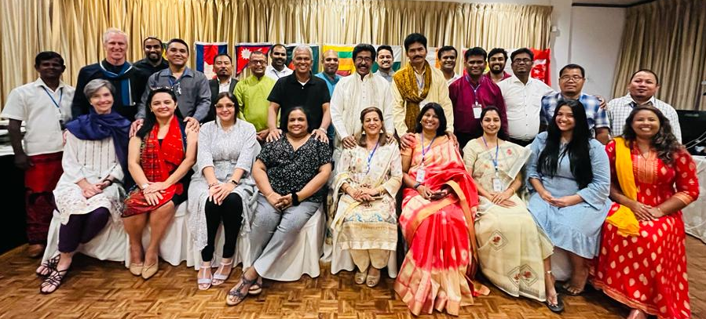
(Below, first South Asia Leader’s Conference – 2022, Sri Lanka)
Questions to Deepen Understanding
1. What was the date of the merger of the Wesleyan Methodist and the Pilgrim Holiness churches?

2. In the development of the Wesleyan Church outside of North America, what was the first mission field of the Pilgrim Holiness Church and what year was it established?

3. Which was the first mission field for the Wesleyan Methodist Church and in what year what it founded?

4. What was the country where the reading of John Wesley’s writings led them to have a revival and ultimately join the Wesleyan Church?

5. What are the two fields where the church has had 3 generations of leaders involved in the development and expansion of the church? (Gujarat, India.)
6. In how many countries around the world is the Wesleyan Church?

7. Which country came to the Wesleyan Church because of a car accident, opening the door for the church and two orphanages?

8. What are the 2 states in northeast India where we have a strong work?
Lesson No 3 Articles of Religion I: The Trinity and Humankind

Article II. Articles of Religion

I. Faith in the Holy Trinity
210. We believe in the one living and true God, both holy and loving, eternal, unlimited in power, wisdom and goodness, the Creator and Preserver of all things. Within this unity there are three persons of one essential nature, power and eternity — the Father, the Son and the Holy Spirit.
Gen. 1:1; 17:1; Ex. 3:13-15; 33:20; Deut. 6:4; Ps. 90:2; Isa. 40:28-29; Matt. 3:16-17; 28:19; John 1:1-2; 4:24; 16:13; 17:3; Acts 5:3-4; 17:24-25; 1 Cor. 8:4, 6; Eph. 2:18; Phil. 2:6; Col. 1:16-17; 1 Tim. 1:17; Heb. 1:8; 1 John 5:20.

II. The Father
212. We believe the Father is the Source of all that exists, whether of matter or spirit. With the Son and the Holy Spirit, He made man, male and female, in His image. By intention He relates to people as Father, thereby forever declaring His goodwill toward them. In love, He both seeks and receives penitent sinners.

Ps. 68:5; Isa. 64:8; Matt. 7:11; John 3:17; Rom. 8:15; 1 Peter 1:17.

III. The Son of God
214. We believe in Jesus Christ, the only begotten Son of God. He was conceived by the Holy Spirit and born of the Virgin Mary, truly God and truly man. He died on the cross and was buried, to be a sacrifice both for original sin and for all human transgressions, and to reconcile us to God. Christ rose bodily from the dead, and ascended into heaven, and there intercedes for us at the Father’s right hand until He returns to judge all humanity at the last day.

Ps. 16:8-10; Matt. 1:21, 23; 11:27; 16:28; 27:62-66; 28:5-9, 16-17; Mark 10:45; 15; 16:6-7; Luke 1:27, 31, 35; 24:4-8, 23; John 1:1, 14, 18; 3:16-17; 20:26-29; 21; Acts 1:2-3; 2:24-31; 4:12; 10:40; Rom. 5:10, 18; 8:34; 14:9; 1 Cor. 15:3-8, 14; 2 Cor. 5:18-19; Gal. 1:4; 2:20; 4:4-5; Eph. 5:2; 1 Tim. 1:15; Heb 2:17; 7:27; 9:14, 28; 10:12; 13:20; 1 Peter 2:24; 1 John 2:2; 4:14.

IV. The Holy Spirit
216. We believe in the Holy Spirit who proceeds from the Father and the Son, and is of the same essential nature, majesty, and glory, as the Father and the Son, truly and eternally God. He is the Administrator of grace to all and is particularly the effective Agent in conviction for sin, in regeneration, in sanctification, and in glorification. He is ever present, assuring, preserving, guiding, and enabling the believer.

Job 33:4; Matt. 28:19; John 4:24; 14:16-17; 15:26; 16:13-15; Acts 5:3-4; Rom. 8:9; 2 Cor. 3:17; Gal. 4:6.

V. The Sufficiency and Full Authority of the Holy Scriptures for Salvation
218. We believe that the books of the Old and New Testaments constitute the Holy Scriptures. They are the inspired and infallibly written Word of God, fully inerrant in their original manuscripts and superior to all human authority and have been transmitted to the present without corruption of any essential doctrine. We believe that they contain all things necessary to salvation; so that whatever is not read therein, nor may be proved thereby, is not to be required of any man or woman that it should be believed as an article of faith or be thought requisite or necessary to salvation. Both in the Old and New Testaments life is offered ultimately through Christ, who is the only Mediator between God and humanity. The New Testament teaches Christians how to fulfill the moral principles of the Old Testament, calling for loving obedience to God made possible by the indwelling presence of His Holy Spirit.

Ps. 19:7; Matt. 5:17-19; 22:37-40; Luke 24:27, 44; John 1:45; 5:46; 17:17; Acts 17:2, 11; Rom. 1:2; 15:4, 8; 16:26; 2 Cor. 1:20; Gal. 1:8; Eph. 2:15-16; 1 Tim. 2:5; 2 Tim. 3:15-17; Heb. 4:12; 10:1; 11:39; James 1:21; 1 Peter 1:23; 2 Peter 1:19-21; 1 John 2:3-7; Rev. 22:18-19.

VI. God's Purpose for Humanity
220. We believe that the two great commandments which require us to love the Lord our God with all the heart, and our neighbors as ourselves, summarize the divine law as it is revealed in the Scriptures. They are the perfect measure and norm of human duty, both for the ordering and directing of families and nations, and all other social bodies, and for individual acts, by which we are required to acknowledge God as our only Supreme Ruler, and all persons as created by Him, equal in all natural rights. Therefore, all persons should so order all their individual, social and political acts as to give to God entire and absolute obedience, and to assure to all the enjoyment of every natural right, as well as to promote the fulfillment of each in the possession and exercise of such rights.

Lev. 19:18, 34; Deut. 1:16-17; Job 31:13-14; Jer. 21:12; 22:3; Micah 6:8; Matt. 5:44-48; 7:12; Mark 12:28-31; Luke 6:27-29, 35; John 13:34-35; Acts 10:34-35; 17:26; Rom. 12:9; 13:1, 7-8, 10; Gal. 5:14; 6:10; Titus 3:1; James 2:8; 1 Peter 2:17; 1 John 2:5; 4:12-13; 2 John 6.
VII. Marriage and the Family
222. We believe that every person is created in the image of God, that human sexuality reflects that image in terms of intimate love, communication, fellowship, subordination of the self to the larger whole, and fulfillment. God’s Word makes use of the marriage relationship as the supreme metaphor for His relationship with His covenant people and for revealing the truth that that relationship is of one God with one people. Therefore, God’s plan for human sexuality is that it is to be expressed only in a monogamous lifelong relationship between one man and one woman within the framework of marriage. This is the only relationship which is divinely designed for the birth and rearing of children and is a covenant union made in the sight of God, taking priority over every other human relationship.

Gen. 1:27-28; 2:18, 20, 23-24; Isa. 54:4-8; 62:5b; Jer. 3:14; Ezek. 16:3ff.; Hosea 2; Mal. 2:14; Matt. 19:4-6; Mark 10:9; John 2:1-2, 11; 1 Cor. 9:5; Eph. 5:23-32; 1 Tim. 5:14; Heb. 13:4; Rev. 19:7-8.

VIII. The Free Will of Man
224. We believe that humanity’s creation in the image of God included ability to choose between right and wrong. Thus, individuals were made morally responsible for their choices. But since the fall of Adam, people are unable in their own strength to do what is right. This is due to original sin, which is not simply following Adam’s example, but rather the corruption of the nature of each mortal and is reproduced naturally in Adam’s descendants. Because of it, humans are very far gone from original righteousness, and by nature are continually inclined to evil. They cannot of themselves even call upon God or exercise faith for salvation. But through Jesus Christ the prevenient grace of God makes possible what humans in self-effort cannot do. It is bestowed freely upon all, enabling all who will to turn and be saved.

Gen. 6:5; 8:21; Deut. 30:19; Josh. 24:15; 1 Kings 20:40; Ps. 51:5; Isa. 64:6; Jer. 17:9; Mark 7:21-23; Luke 16:15; John 7:17; Rom. 3:10-12; 5:12-21; 1 Cor. 15:22; Eph. 2:1-3; 1 Tim. 2:5; Titus 3:5; Heb. 11:6; Rev. 22:17.

Questions to Deepen Understanding
1. What are the three parts of the Trinity and how can we understand that they are part of the one true God? (cp. 210)

2. We believe that the Bible is inspired and infallible. What does that mean? For example, in relation to the birth of Christ who was born of the Virgin Mary, what that true or this just a myth or symbolism? (cp. 214 and 218)

3. The Bible is without error but is it possible that the Bible does not contain all the things necessary for salvation and a holy life?(cp. 218)

4. What is God's purpose for man? (cp.220)

5. Since we have free will, we alone can exercise faith for salvation. True False Justify your answer. (cp.224)

6. Does God's grace reach some people or all people? Explain.

Lesson No 4- Articles of Religion II: Salvation and Sanctification
IX. Atonement
226. We believe that Christ’s offering of himself, once and for all, through His sufferings and meritorious death on the cross, provides the perfect redemption and atonement for the sins of the whole world, both original and actual. There is no other ground of salvation from sin but that alone. This atonement is sufficient for every individual of Adam’s race. It is unconditionally effective in the salvation of those mentally incompetent from birth, of those converted persons who have become mentally incompetent, and of children under the age of accountability. But it is effective for the salvation of those who reach the age of accountability only when they repent and exercise faith in Christ.

Isa. 52:13—53:12; Luke 24:46-47; John 3:16; Acts 3:18; 4:12; Rom. 3:20, 24-26; 5:8-11, 13, 18-20; 7:7; 8:34; 1 Cor. 6:11; 15:22; Gal. 2:16; 3:2-3; Eph. 1:7; 2:13, 16; 1 Tim. 2:5-6; Heb. 7:23-27; 9:11-15, 24-28; 10:14; 1 John 2:2; 4:10.

X . Repentance and Faith
228 . We believe that for men and women to appropriate what God’s prevenient grace has made possible, they must voluntarily respond in repentance and faith. The ability comes from God, but the act is the individual’s.

Repentance is prompted by the convicting ministry of the Holy Spirit. It involves a willful change of mind that renounces sin and longs for righteousness, a godly sorrow for and a confession of past sins, proper restitution for wrongdoings, and a resolution to reform the life. Repentance is the precondition for saving faith, and without it saving faith is impossible. Faith, in turn, is the only condition of salvation. It begins in the agreement of the mind and the consent of the will to the truth of the gospel, but issues in a complete reliance by the whole person in the saving ability of Jesus Christ and a complete trusting of oneself to Him as Savior and Lord. Saving faith is expressed in a public acknowledgment of His Lordship and an identification with His Church.

Mark 1:15; Luke 5:32; 13:3; 24:47; John 3:16; 17:20; 20:31; Acts 5:31; 10:43; 11:18; 16:31; 20:21; 26:20; Rom. 1:16; 2:4; 10:8-10, 17; Gal. 3:26; Eph. 2:8; 4:4-6; Phil. 3:9; 2 Thess. 2:13; 2 Tim. 2:25; Heb. 11:6; 12:2; 1 Peter 1:9; 2 Peter 3:9.

XI. Justification and Regeneration
230. We believe that when one repents of personal sin and believes on the Lord Jesus Christ, that at the same moment that person is justified, regenerated, adopted into the family of God, and assured of personal salvation through the witness of the Holy Spirit.

We believe that justification is the judicial act of God whereby a person is accounted righteous, granted full pardon of all sin, delivered from guilt, completely released from the penalty of sins committed, by the merit of our Lord and Savior Jesus Christ, by faith alone, not on the basis of works.
We believe that regeneration, or the new birth, is that work of the Holy Spirit whereby, when one truly repents and believes, one’s moral nature is given a distinctively spiritual life with the capacity for love and obedience. This new life is received by faith in Jesus Christ, it enables the pardoned sinner to serve God with the will and affections of the heart, and by it the regenerate are delivered from the power of sin which reigns over all the unregenerate.
We believe that adoption is the act of God by which the justified and regenerated believer becomes a partaker of all the rights, privileges and responsibilities of a child of God.

Justification: Hab. 2:4; Acts 13:38-39; 15:11; 16:31; Rom. 1:17; 3:28; 4:2-5; 5:1-2; Gal. 3:6-14; Eph. 2:8-9; Phil 3:9; Heb. 10:38.
Regeneration: John 1:12-13; 3:3, 5-8; 2 Cor. 5:17; Gal. 3:26; Eph. 2:5, 10, 19; 4:24; Col. 3:10; Titus 3:5; James 1:18; 1 Peter 1:3-4; 2 Peter 1:4; 1 John 3:1.
Adoption: Rom. 8:15; Gal. 4:5, 7; Eph. 1:5.
Witness of the Spirit: Rom. 8:16-17; Gal. 4:6; 1 John 2:3; 3:14, 18-

XII. Good Works
232. We believe that although good works cannot save us from our sins or from God’s judgment, they are the fruit of faith and follow after regeneration. Therefore, they are pleasing and acceptable to God in Christ, and by them a living faith may be as evidently known as a tree is discerned by its fruit.

Matt. 5:16; 7:16-20; John 15:8; Rom 3:20; 4:2, 4, 6; Gal. 2:16; 5:6; Eph. 2:10; Phil. 1:11; Col. 1:10; 1 Thess. 1:3; Titus 2:14; 3:5; James 2:18, 22; 1 Peter 2:9, 12.

XIII. Sin after Regeneration
234. We believe that after we have experienced regeneration, it is possible to fall into sin, for in this life there is no such height or strength of holiness from which it is impossible to fall. But by the grace of God one who has fallen into sin may by true repentance and faith find forgiveness and restoration.

Mal. 3:7; Matt. 18:21-22; John 15:4-6; 1 Tim. 4:1, 16; Heb. 10:35-39; 1 John 1:9; 2:1, 24-25.

XIV. Sanctification: Initial, Progressive, Whole
236. We believe that sanctification is that work of the Holy Spirit by which the child of God is separated from sin for God and is able to love God with all his heart and to walk in all His holy commandments without reprimand. Sanctification begins at the moment of justification and regeneration. From that moment there is a gradual or progressive sanctification just as the believer walks with God and grows daily in grace and in a more perfect obedience to God. This prepares for the crisis of complete sanctification that takes place instantly when the believer presents himself as a living sacrifice, holy and acceptable to God, by faith in Jesus Christ, being affected by baptism with the Holy Spirit who purifies the heart of all inborn sin. The crisis of complete sanctification perfects the believer in love and empowers him for effective service. This is followed by a lifetime growth in the grace and knowledge of our Lord and Savior, Jesus Christ. The life of holiness continues by faith in the sanctifying blood of Christ and is evident by loving obedience to God's revealed will.

Gen. 17:1; Deut. 30:6; Ps. 130:8; Isa. 6:1-6; Ezek. 36:25-29; Matt. 5:8, 48; Luke 1:74-75; 3:16-17; 24:49; John 17:1-26; Acts 1:4-5, 8; 2:1-4; 15:8-9; 26:18; Rom. 8:3-4; 1 Cor. 1:2; 6:11; 2 Cor. 7:1; Eph. 4:13, 24; 5:25-27; 1 Thess. 3:10, 12-13; 4:3, 7-8; 5:23-24; 2 Thess. 2:13; Titus 2:11-14; Heb. 10:14; 12:14; 13:12; James 3:17-18; 4:8; 1 Peter 1:2; 2 Peter 1:4; 1 John 1:7, 9; 3:8-9; 4:17-18; Jude 24.

XV. The Gifts of the Spirit
238. We believe that the Gift of the Spirit is the Holy Spirit himself, and He is to be desired more than the gifts of the Spirit which He in His wise counsel bestows upon individual members of the Church to enable them properly to fulfill their function as members of the body of Christ. The gifts of the Spirit, although not always identifiable with natural abilities, function through them for the edification of the whole Church. These gifts are to be exercised in love under the administration of the Lord of the Church, not through human volition. The relative value of the gifts of the Spirit is to be tested by their usefulness in the Church and not by the ecstasy produced in the ones receiving them.

Luke 11:13; 24:49; Acts 1:4; 2:38-39; 8:19-20; 10:45; 11:17; Rom. 12:4-8; 1 Cor. 12:1—14:40; Eph. 4:7-8, 11-16; Heb. 2:4; 13:20-21; 1 Peter 4:8-11.

Questions to Deepen Understanding
1. If we have not been saved by our works, how are we saved, then? (cp. 230)

2. What would be the evidence of a living faith, according to the Bible? (cp. 232)

3. Is there a moment in a believer's life when the Holy Spirit cleanses him of all inborn sin? (cp. 236)

4. What are the two things that happen in the believer when the Holy Spirit sanctifies entirely? (cp.236)

5. Does the Wesleyan Church believe in spiritual gifts? (cp. 238)
Yes or No

6. What is the value of these gifts to the church? What is the purpose of these gifts for the church?

Lesson No. 5 - Articles of Religion III: The Church and the Last Things
XVI. The Church
240. We believe that the Christian Church is the entire body of believers in Jesus Christ, who is the founder and only Head of the Church. The Church includes both those believers who have gone to be with the Lord and those who remain on the earth, having renounced the world, the flesh, and the devil, and having dedicated themselves to the work which Christ committed unto His church until He comes. The Church on earth is to preach the pure Word of God, properly administer the sacraments according to Christ’s instructions, and live in obedience to all that Christ commands. A local church is a body of believers formally organized on gospel principles, meeting regularly for the purposes of evangelism, nurture, fellowship and worship. The Wesleyan Church is a denomination consisting of those members within district conferences and local churches who, as members of the body of Christ, hold the faith set forth in these Articles of Religion of The Wesleyan Church and acknowledge the ecclesiastical authority of its governing bodies.

Matt. 16:18; 18:17; Acts 2:41-47; 9:31; 11:22; 12:5; 14:23; 15:22; 20:28; 1 Cor. 1:2; 12:28; 16:1; 2 Cor. 1:1; Gal. 1:2; Eph. 1:22-23; 2:19-22; 3:9-10, 21; 5:22-33; Col. 1:18, 24; 1 Thess. 1:1; 2 Thess. 1:1; 1 Tim. 3:15; Heb. 12:23; James 5:14.

XVII. The Sacraments: Baptism and the Lord's Supper
242. We believe that water baptism and the Lord’s Supper are the sacraments of the church commanded by Christ and ordained as a means of grace when received through faith. They are tokens of our profession of Christian faith and signs of God’s gracious ministry toward us. By them, He works within us to quicken, strengthen, and confirm our faith.
We believe that water baptism is a sacrament of the church, commanded by our Lord and administered to believers. It is a symbol of the new covenant of grace and signifies acceptance of the benefits of the atonement of Jesus Christ. By means of this sacrament, believers declare their faith in Jesus Christ as Savior.

Matt. 3:13-17; 28:19; Mark 1:9-11; John 3:5, 22, 26; 4:1-2; Acts 2:38-39, 41; 8:12-17, 36-38; 9:18; 16:15, 33; 18:8; 19:5; 22:16; Rom 2:28-29; 4:11; 6:3-4; 1 Cor. 12:13; Gal. 3:27-29; Col. 2:11-12; Titus 3:5.

We believe that the Lord’s Supper is a sacrament of our redemption by Christ’s death and of our hope in His victorious return, as well as a sign of the love that Christians have for each other. To such as receive it humbly, with a proper spirit and by faith, the Lord’s Supper is made a means through which God communicates grace to the heart.

Matt. 26:26-28; Mark 14:22-24; Luke 22:19-20; John 6:48-58; 1 Cor. 5:7-8; 10:3-4, 16-17; 11:23-29.

XVIII. The Second Coming of Christ
244. We believe that the certainty of the personal and imminent return of Christ inspires holy living and zeal for the evangelization of the world. At His return He will fulfill all prophecies made concerning His final and complete triumph over evil.

Job 19:25-27; Isa. 11:1-12; Zech. 14:1-11; Matt. 24:1-51; 25; 26:64; Mark 13:1-37; Luke 17:22-37; 21:5-36; John 14:1-3; Acts 1:6-11; 1 Cor. 1:7-8; 1 Thess. 1:10; 2:19; 3:13; 4:13-18; 5:1-11, 23; 2 Thess. 1:6-10; 2:1-12; Titus 2:11-14; Heb. 9:27-28; James 5:7-8; 2 Peter 3:1-14; 1 John 3:2-3; Rev. 1:7; 19:11-16; 22:6-7, 12, 20

XIX. The Resurrection of the Dead
246. We believe in the bodily resurrection from the dead of all people—of the just unto the resurrection of life, and of the unjust unto the resurrection of damnation. The resurrection of Christ is the guarantee of the resurrection which will occur at Christ’s Second Coming. The raised body will be a spiritual body, but the person will be whole and identifiable.

Job 19:25-27; Dan. 12:2; Matt. 22:30-32; 28:1-20; Mark 16:1-8; Luke 14:14; 24:1-53; John 5:28-29; 11:21-27; 20:1—21:25; Acts 1:3; Rom. 8:11; 1 Cor. 6:14; 15:1-58; 2 Cor. 4:14; 5:1-11; 1 Thess. 4:13-17; Rev. 20:4-6, 11-13.

XX. The Judgment of All Persons
248. We believe that the Scriptures reveal God as the Judge of all, and the acts of His judgment are based on His omniscience and eternal justice. His administration of judgment will culminate in the final meeting of all persons before His throne of great majesty and power, where records will be examined, and final rewards and punishments will be administered.

Eccl. 12:14; Matt. 10:15; 25:31-46; Luke 11:31-32; Acts 10:42; 17:31; Rom. 2:16; 14:10-12; 2 Cor. 5:10; 2 Tim. 4:1; Heb. 9:27;
2 Peter 3:7; Rev. 20:11-13.
.
XXI. Destiny
250. We believe that the Scriptures clearly teach that there is a conscious personal existence after death. The final destiny of each person is determined by God’s grace and that person’s response, evidenced inevitably by a moral character which results from that individual’s personal and volitional choices and not from any arbitrary decree of God. Heaven with its eternal glory and the blessedness of Christ’s presence is the final abode of those who choose the salvation which God provides through Jesus Christ, but hell with its everlasting misery and separation from God is the final abode of those who neglect this great salvation.

Dan. 12:2; Matt. 25:34-46; Mark 9:43-48; Luke 13:3; John 8:21-23; 14:2-3; 2 Cor. 5:6, 8, 10; Heb. 2:1-3; 9:27-28; 10:26-31; Rev. 20:14-15; 21:1—22:5, 14-15.

Questions to Deepen
- What is the "Christian Church"? What is a local church? What is the Wesleyan Church? (cp. 240)

- What does it mean by the “means of grace”? Why is the Lord’s Supper and baptism considered a means of grace? (cp. 242)

- Is the Lord’s Supper only for those who deserve it? (cp. 242)

- Jesus Christ will return! Do you believe that? (cp. 244 to 246)

- The Bible says all are going to be judged. How will God judge? Is it arbitrary? (cp.248)

- Does hell exist? How do you explain the existence of hell if God is a God of love? (cp. 250)

Lesson No. 6 - Commitments of Membership I: God, You and the Family
Article III. Commitments of Full Membership
260. To be identified with an organized church is the blessed privilege and sacred duty of all who are saved from their sins and are seeking completeness in Christ Jesus. From the Church's beginnings in the New Testament age, it has been understood that such identification involves putting off the old patterns of conduct and putting on the mind of Christ. In maintaining this Christian concept of a transformed life, The Wesleyan Church intends to relate timeless biblical principles to the conditions of contemporary society in such a way as to respect the integrity of the individual believer, yet maintain the purity of the Church and the effectiveness of its witness. This is done in the conviction that there is validity in the concept of the collective Christian conscience as illuminated and guided by the Holy Spirit.
265. Those admitted to Full Membership in our churches commit themselves to demonstrate their life in Christ in such ways as:

Toward God
(1) To reverence the name of God and to honor the Lord's Day by divine worship and spiritual edification, participating in those activities which contribute to the moral and spiritual purposes of this day

Gen. 2:3; Ex. 20:3, 7-11; Deut. 5:11-15; Isa. 58:13-14; Mark 2:27; Acts 20:7; Heb. 4:9.

(2) To seek only the leading of the Holy Spirit and to abstain from all forms of spiritism, such as the occult, witchcraft, astrology, and other similar practices.
Lev. 19:31; 20:6; Deut. 18:10-14; Acts 19:18-19; Gal. 5:19-20.

2. Toward Self

(3) To exercise faithful stewardship through the wise use of their time and material resources, practicing careful self-discipline in order to further the mission of Christ's church (remembering the principle of tithing which is basic to the New Testament standard of stewardship) and to demonstrate compassion to those in need.

Prov. 3:9; Mal. 3:10; Matt. 25:34-40; Acts 20:35; 1 Cor. 16:2;
2 Cor. 9:7; Eph. 5:16; Col. 3:17; James 2:15-16; 1 John 3:17.

(4) To demonstrate a positive social witness by abstaining from all forms of gambling and by abstaining from using or trafficking (production, sale or purchase) in any substances destructive to their physical, mental and spiritual health, such as alcoholic beverages, tobacco and drugs (other than proper medical purposes of drugs);

Ex. 20:17; Rom. 14:21; 1 Cor. 6:12.

Gambling violates the principle of Christian stewardship and the tenth commandment, is harmful to the individual in that it is emotionally addictive, is a poor example to others, and pollutes the moral climate of society.

Prov. 20:1; Rom. 6:12; 14:21; 1 Cor. 6:12-20; 10:23; 2 Cor. 7:1; Eph. 5:18; 1 Thess. 5:12.

Christians are to regard their bodies as temples of the Holy Spirit. While no "thing" of itself is sinful, the Christian should avoid the use of anything which would not help build the fellowship of the church, would not help the believers to realize their full potential in Christ, or which would enslave them. In the light of the scientific knowledge of our day concerning the actual and potential harm of these substances, total abstinence is more in keeping with these biblical principles than is moderation.

Ex. 20:3; Matt. 5:34-36; John 18:20; Acts 4:12; James 5:12.

3. Toward Family
(5) To follow the teachings of the Scriptures regarding marriage and divorce. We affirm that sexual relationships outside of marriage and sexual relationships between persons of the same sex are immoral and sinful. We further affirm that heterosexual monogamy is God's plan for marriage, and we regard sexual sin of the spouse, such as adultery, homosexual behavior, bestiality or incest, as the only biblical grounds for considering divorce, and then only when appropriate counseling has failed to restore the relationship.

Ex. 20:14, 17; 22:19; Lev. 20:10-16; Matt. 5:32; 19:19; Mark 10:11-12; Luke 16:18.

(6) To preserve the sanctity of the home by honoring Christ in every phase of family life and by demonstrating Christlike love (always avoiding spousal or child abuse), and by living peacefully with one another, thereby encouraging the nurture and education of the children to the Christian faith so as to bring them early to the saving knowledge of Christ.

Prov. 22:6; Mark 10:9; Eph. 5:28; 6:4.

Questions to Deepen Understanding
- Give a description of The Wesleyan Church, showing its purpose. (cp. 260)

- What activities do not contribute to your spiritual well-being?
(cp. 265:4)

- Can you explain why the Wesleyans don't drink? (cp. 265:4)

Lesson No 7 - Commitments of Member II: The Church and Others
With Respect to the Church
(12) To work together for the advancement of God's kingdom and for the mutual edification of fellow believers in holiness, knowledge, and love; to walk together in Christian fellowship by giving and receiving counsel with gentleness and affection; by praying for each other; by helping each other in sickness and distress; and by demonstrating love, purity and courtesy to all.
Rom. 15:1-2; Eph. 4; 1 Thess. 5

(13) To grow in the knowledge, love and grace of God by participating in public worship, the ministry of the Word of God and the Lord's Supper.

Mark 2:18-20; Acts 13:2-3; 14:23; Rom. 12:12; 1 Cor. 11:23-28; Eph. 6:18; Phil. 4:6; 1 Tim. 2:1-2; 2 Tim. 3:16-17; Heb. 10:25; 1 Peter 2:2; 2 Peter 3:18.

(14) To preserve the fellowship and witness of the Church with reference to the use of languages. The Wesleyan Church believes in the miraculous use of languages and the interpretation of languages in the biblical and historical setting. But it is contrary to the Word of God to teach that speaking in an unknown tongue or the gift of tongues is the evidence of the baptism of the Holy Spirit or of that entire sanctification which the baptism accomplishes; therefore, only a language readily understood by the congregation is to be used in public worship.

Acts 8:14-17; 1 Cor. 12:1—14:40; Gal. 5:22-24.

- Towards Others
(16) To do good as much as possible to all people as God gives opportunity; especially to those in the body of Christ; by giving food to the hungry, by clothing the destitute, by visiting or helping those who are sick or in prison; by instructing, correcting, or encouraging them in love.

Matt. 25:31-46; Eph. 5:11; 1 Thess. 5:14; Heb. 3:13; 10:23-25.
.
(17) Respect the inherent individual rights of all persons, without regard to race, color, or sex.

1 Cor. 8:13; 12:13; Gal. 3:28; 1 Tim. 5:21

(18) Live honestly, be just in all business dealings and faithful to all commitments.

Eccl. 5:4-5; Rom. 12:17; Phil. 4:8-9; 1 Peter 2:12.

268. These are the Full Membership Commitments of our Church. We believe all these to be consistent with the principles of Christ as taught in the Word of God, which is the only and sufficient rule both of our faith and practice. If any among us do not observe them, and/or habitually break any of them, we will admonish such persons in love with the hope of restoring them to lives of harmony with the above Full Membership Commitments. If such efforts of restoration continue to prove fruitless, official action should be taken toward termination of said person's church membership. However, the church members are encouraged to continue efforts toward the spiritual restoration of these persons.

Matt. 18:15-17; 1 Cor. 5:6-7, 9-13; 2 Cor. 2:5-7; 5:18-20; 6:14-18; Gal. 6:1-10; Eph. 4:25-32; Titus 3:10-11.

Questions to Deepen Understanding
- What would be the necessary condition for speaking in strange languages in a Wesleyan church and why? What are the verses supporting this? (cp. 265:15)

- How should we act towards others? What kinds of things should the church do to help others? (cp. 265:16)

- What do we do when someone in the church lives dishonestly? (Example: Do you keep honest accounts?) (cp. 265:18)

- What is the only and sufficient rule of our faith and practice? (cp. 268)

- What should you do if a member of the Church is not keeping the commitments of membership? (cp. 268)

Lesson No 8 - Suggestions for the Christian Life
Beloved brother, you have taken a very important step in your life; it was a decisive, transformative, and renewing step, because through it you decided to start a new life. God has become your heavenly Father, and you are now His child. Therefore, there are some things that are important for the maintenance and growth of your spiritual life. We will then give suggestions that will assist you in your Christian life.

1. Christian Witness
One of the best ways to keep a vibrant faith is to guide others to Christ. You are to be a light to the world and allow the light to shine through you, at every opportunity. Sharing about what the Lord Jesus has done in your life is an easy way to talk about Christ.
You are now an ambassador of God. Testify to the things you have seen, heard, and experienced.

Rm. 5:8; 11; Acts. 1:18; 22:15; Rev. 12.

2. Temptation
Many people think that when they are saved, they will be free from temptation, but this is not true; all believers are tempted. The Bible says in 1 Peter 5:8-9 “Be sober-minded; be watchful. Your adversary the devil prowls around like a roaring lion, seeking someone to devour. 9 Resist him, firm in your faith…”.
We can resist the devil and overcome temptations by praying, reminding the devil that our sins are covered by the blood of Christ (Rev. 12:11), praising God, singing a hymn, or thinking of verses from the Bible, and not arguing with Satan, for the Lord is the one who fights for us.
3. A Balanced Life
The tendency towards extremes is a characteristic of humanity. The believer, however, cannot let emotions take control. Emotions are not religion. The joy and peace that the believer enjoys are the result of a life of fellowship with God. Emotions rise and fall, but the believer's faith in the eternal God must be firm as a rock.
4 . Stewardship: Uses of Life and Goods
Christian life is not just worship and bible reading. It includes careful stewardship of all that we are and all that we have. The believer no longer belongs to himself, but to God.
Every believer has the responsibility to spread the Gospel, but this is only possible when every child of God obeys the teachings of His Word regarding tithes and offerings. The Bible teaches that the believer should give a tenth of their salary or income to sustain God's work. The giving of tithes and offerings is the result of a grateful heart for the many blessings received from God. When there is genuine love, giving is a real joy. It is important to start this practice immediately and give regularly to your church. (1 Cor. 16:1-2). But give it freely, whatever you desire, and the Lord will help you prosper. The believer who does this will learn that "it is more blessed to give that to receive" (Acts 20:35). Malachi. 3:8-10; Luke 6:38.

Questions to Go Deeper
1. What does the word "tithing" mean? What is the position of the Wesleyan Church in relation to money? Do you agree with the church's position? Defend your position using the Bible.

2 . We know that temptation and maintaining a balanced life are areas of struggle and sometimes defeat for everyone. How can you keep your balance and resist temptation? How can others help you?
Lesson No 9 - Membership and Leadership
- Provisional Member
558. Those who are converted to Christ but who are not yet able to assume the responsibilities of full membership, or because they are immature in Christ or in age (Junior Member), will be received as provisional members. For Junior members, if they are attending and part of the family, no ritual is necessary, but one can be used if it is meaningful.

560. The rights of the provisional member are:
(1) The fellowship of the saints and the encouragement, admonition, and guidance of the ministry.
(2) Access to the sacraments and rituals of the Church. (This does not mean that the Wesleyan Church practices closed communion: cp. 5605; 5615.)
(3) Eligibility for any position in the local church except those reserved by the Manual for full membership,

- Full Member
297. The conditions for full membership are:
(1) Candidates for full membership shall be examined as provided for by the local church board (782:7), to determine whether they meet the requirements for membership including their experience of regeneration, Christian baptism, their acceptance of the Articles of Religion of The Wesleyan Church, the Full Membership Commitments and the authority of The Discipline in matters of church government, and their willingness to enter into full membership with the Church.
(2) Candidates for full membership who have satisfactorily passed the examination by the local church board, shall be voted upon by the local church conference
(3) Persons who have been accepted for full membership should be formally received into full membership in a public service, in which they shall make their confession and vows public.
302. The rights of the full member are:
(1) Christian fellowship of the other believers and the encouragement, admonition, and spiritual guidance from the pastor.
(2) The right to partake of the sacraments of the Church.
(3) The right to vote and to hold any office in the church.
(4) The right to trial and appeal if charged with failure to maintain the conditions of membership, with the specific provision that joining another religious body shall of itself cut off membership in the Church.
(5) A member in good standing in any Wesleyan Church may transfer membership to another Wesleyan Church

Government and Leadership

As a member of the Wesleyan Church, it is good to know how it works, who the leaders are, and how you can participate in the life and ministry of your church.
Local Church Conference - The highest authority in the local church is the local church conference in which all full members of the church can participate. The assembly meets only once a year to make the larger decisions and elect church leadership. Also, leaders will report on what has happened during the past year. In the assembly the church elects the pastor and the board, so it is the highest authority in the local church.
Local Board of Administration - The local church conference is the highest authority; however, it is the local board of administration that leads the church during the year. By its name you can understand the role of the board – to help the church in the area of administration, freeing the pastor (the spiritual leader) to devote himself to the Word and prayer (Acts 6:1-4). What is administrative work in the church? Financial issues, building maintenance, construction, church events and calendar, the fulfillment of the church's mission to win souls and disciple them, Sunday School, Christian education, music, and the Worship service, all this and more are the responsibilities of the board. Let's see who is part of the board and the function of each member. This is important because you, as a full member, can be part of the board!
Secretary – is the person who takes care of the statistics and documents of the church. For example, at the end of the fiscal year a statistical report will be made that will tell how many members there are, how many worship services have been held, what was the average attendance, how many people have been saved in the worship services, how many people have been baptized, etc. These statistics are important because it has to do with the purpose of the church which is to win souls, to make disciples, and to advance the kingdom of God. The secretary also takes care of church documents by keeping the minutes of board meetings, archiving important records, and even recording church history, such as the church's birthday date and others.
Treasurer – The treasurer is to receive, hold, and pay out all money of the local church, as ordered by the local church conference or the local church board. Also, the treasurer is to help the pastor keep complete and accurate records of all money taken in and of the way in which they are paid out. Also, the treasurer will make monthly reports to the local church board and make reports to all regular meetings of the local church conference about the finances of the church.
Superintendent of the Sunday School – The Sunday school superintendent will have supervision of the Sunday school, consult with the pastor or board on all major decisions, and to promote interest in and attendance in Sunday school. Also, the superintendent will have immediate supervision of each meeting of the Sunday school, seeing that each department and class has the necessary teachers and that order is maintained. The superintendent will promote the study of the Word of God, offer training for the teachers, and encourage the church in the making of disciples.
Trustee - The trustees take the weight off the pastor and zealously care for the things of God pertaining to the building, equipment and grounds. The trustees normally help with the Lord’s Supper and are overall lay leaders. They must be people who are mature in the faith and deeply spiritual.
Member-at-large – The member-at-large is a person who has the trust of the congregation and who can represent the people of the church in general. This member is a wise and experienced person who can help the church make decisions and guide the church in fulfilling the church's mission.
Questions to Deepen
1. What are the rights of a full member? (cp. 302)

2. What is the difference between the provisional member and the full member?

3. Who chooses the pastor when needed? (II: 302:3)

4 . Describe the role of church officers, listed below:
a. Secretary:

b. Trustee:

c. Superintendent of The Sunday School:

d. Member-at-large:

5. What are the monthly tasks of the church treasurer?

Lesson 10
Baptism
Main Text: John 3:5-7
Key Verse: John 3:5
Introduction:

Baptism is an act that marks you as someone who belongs to God's family. Whether you’re preparing for baptism or have already been baptized, since it is an important part of Christianity, we want to take time to better understand what this process looks like and in particular how it works in the Evangelical Wesleyan Church. To learn more about it, let's look at the Bible and see what it says, starting with John 3:5-7.
Readings: John 3:5-7, (additional texts—Acts 8:36-38, Colossians 2:11-12)
Discussion Questions:
John 3:5-7:
Who cannot enter the kingdom of God? (vs. 5)

What does "being born of water" mean? (vs. 5)

What does "being born of the Spirit" mean? (vs. 6)

What is the difference between flesh and spirit? (vs. 6)

What does "being born again" mean? (vs. 7)

Activity:
Now, for a game! This game is called word search and is simple: Try to find words that are hidden among many other letters. The words can also be written backward, or diagonally. Look for these words: baptism, water, Lord, born, grace.
Y | O | R | D | A | J | H | W | L | Q | W | F | E | T | Q
T | D | R | O | L | W | A | Z | U | A | S | G | C | R | S
B | A | P | T | I | S | M | I | T | E | D | H | A | P | U
E | O | T | B | I | C | D | E | M | C | A | K | R | N | W
N | L | R | K | R | O | R | V | F | B | R | J | G | I | X
M | A | I | N | G | Y | P | S | E | A | G | O | M | L | Y

What does the Church Manual say about Baptism?
The Church Manual shows the Wesleyan Church's position on baptism. It says this:
- We believe that baptism with water and the Lord's Supper are the sacraments of the church, given by Christ and ordained as means of grace when received by faith. They are marks of our profession of the Christian faith, and signs of God's gracious ministry to us. For through them, He works within us to quicken, strengthen, and confirm our faith.
We believe that baptism with water is a sacrament of the church, ordained by our Lord and administered to believers. It is a symbol of the new covenant of grace and signifies acceptance of the benefits of the Salvation in Jesus Christ. Through this sacrament, believers declare their faith in Jesus Christ as Savior.
Some say that baptism is an external sign of an internal transformation, but it is more than simply an external sign. It is a "means of grace," ordained of God. It creates a stronger bond between us and Him, and God works in us and blesses us when we obey Him.
Baptism
Now that we know more about baptism, let's look at the process, and how it will happen.
First, the church will organize an event. The details of the event depend on the individual, local church. But it will include water, and usually the person getting baptized will be submerged in the water. Traditionally, the baptism candidate will share their testimony before the congregation. When the time comes, the candidate for baptism will come forward, and will answer some questions.
When candidates are presented before the minister, the minister will say:
"Dear friends, according to the example of Jesus, you will present yourselves today to receive the sacrament of baptism. Baptism is not the way to salvation, but rather an outward sign of the new birth that God has worked in your hearts. Baptism proclaims to all the world that you have received Christ Jesus as the Lord of your lives, and that it is your desire to always obey Him. So that we may hear your testimony of what God has done for you, and so that we may know that you understand the meaning of this step you are taking, we shall ask you these questions:
“Do you believe in God the Father, the Son, and the Holy Spirit? That Jesus Christ the Son suffered in your place on the cross, that He died, but was resurrected, that He now sits at the right hand of the Father until He returns to judge all the people on the last day? And do you believe that the Holy Scriptures are the inspired Word of God? That by the grace of God each person has the ability and responsibility to choose between good and evil, and that those who repent of their sins and believe in the Lord Jesus Christ are justified by faith?”
Answer: All this I firmly believe.
“Do you intend for this act to testify to the whole world that you are a believer in Christ and that you will be His follower?”
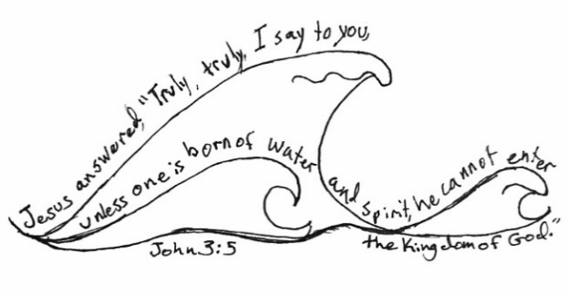
Answer: This I intend, and so I will be.
Then the minister will ask each candidate for their name, saying: “_________, I baptize you in the name of the Father and the Son and the Holy Spirit." And then the minister will immerse the candidate in water—or, if desired, sprinkled or water poured on the head—followed by a closing prayer.
Key Verse: John 3:5 – Jesus answered, “Truly, truly, I say to you, unless one is born of water and Spirit, he cannot enter the kingdom of God.
Weekly Challenge:
- Talk to the pastor and see when it will work to be baptized.
- Congratulations! You have completed the third book!

A Time and a Reason to Sing – “It Is Well”

It’s one of the most beloved and recognizable hymns of all time. Many have sung its words for comfort, strength, and peace during difficult times. The origins of this hymn can be traced back to an event that happened in the life of Horatio Spafford, a prominent lawyer from Chicago who lost his four daughters in a shipwreck on their way to Europe in 1873. Despite this incredible tragedy, he responded with a faith so strong that he was able to write in the midst of anguish the lyrics of “It is Well”. It is another song that is a testimony to the Lord our Father, a powerful testimony that continues to speak today.

1. When peace like a river attendeth my way,
when sorrows like sea billows roll;
whatever my lot, thou hast taught me to say,
"It is well, it is well with my soul."

Refrain (may be sung after final stanza only):
It is well with my soul;
it is well, it is well with my soul.

2. Though Satan should buffet, though trials should come,
let this blest assurance control:
that Christ has regarded my helpless estate,
and has shed his own blood for my soul. Refrain

3. My sin oh, the bliss of this glorious thought!
my sin, not in part, but the whole,
is nailed to the cross, and I bear it no more;
praise the Lord, praise the Lord, O my soul! Refrain

4. O Lord, haste the day when my faith shall be sight,
the clouds be rolled back as a scroll;
the trump shall resound and the Lord shall descend;
even so, it is well with my soul. Refrain
Discipleship Material
Transcultural – Global - Adaptable

5 Books that form a plan of discipleship,
and prepare people to serve the Lord.


First Steps Growing in Our History Our Mission - Which Will Be
In Christianity Christ! and Beliefs Multiplication My Ministry?

Unless otherwise indicated, all the Scriptures that are quoted in English
will be from the ESV version of the Bible

Please adapt and translate this material for your needs. Also use the QR Code or link below, to evaluate the material and inform us how it is being used. The purpose is merely to have feedback about the material and to help us with any errors that we may have missed. There are no copyrights or restrictions in the use of this material. All glory is given to God for this project. Go, make disciples of all nations! Blessings.

Discipleship Material Evaluation Form





The Wesleyan Workshop

wesleyanchurchlk@gmail.com

